SimPhonics’ Method of Meeting FAA Level D Sound Requirements
Contents
Overview 3
FAA Acceptance Criteria 4
Level C and D: 5
Level D: 6
Procedure for Meeting Level D Requirements 7
Data Acquisition (Recording) 8
Pre-Analysis 9
Sound Modeling/System Generation 10
Post Analysis and Tuning 11
Level D Certification Tests 12
Further References: 13

Overview

SimPhonics’ produces high fidelity audio systems for the simulation and training industry. Our systems are unique, in that sound is generated dynamically in response to a simulation model. In order for our customers to determine the accuracy of our systems, SimPhonics has established a standard procedure for simulator sound system acceptance testing that complies with the Federal Aviation Administrations National Simulator Program’s Level D acceptance testing criteria.

The only established acceptance criteria for the specification and/or acceptance of simulator audio systems has been established by the Federal Aviation Administration. Other government and commercial agencies occasionally adopt these guidelines when specifying or accepting a simulation device. Commercial simulation devices intended for airmen certification by the FAA have been certified using these requirements.

Typically, there are two methods in use today regarding the acceptance of simulation devices; 1) FAA Level Requirements (Circular 120-40B), 2) Manual Tuning With a Subject Matter Expert. Unfortunately both methods are equally subjective and leave the interpretation and implementation up to individuals on both sides. This document covers the Level D certification process.

FAA Acceptance Criteria

The following quotes in italic bold are excerpts from FAA documents:

Circular 120-45A, Training Device

"Significant cockpit sounds which result from pilot actions corresponding to those of the airplane. Sound of precipitation, windshield wipers, and other significant airplane noises perceptible to the pilot during normal, abnormal, or emergency operations, as may be appropriate."

Clearly “Significant” is subjective. The only real requirements here are that these simulators will include sounds for the precipitation and windshield wipers. Something that seems trivial compared to other sounds that should be included.

Circular 120-40B, Simulator

"Prior to arrival for an on-site evaluation, the FAA inspector will notify the operator if any tests are planned to be run that may require special equipment or technicians. These tests would include latencies, control dynamics, sounds and vibrations, or motion system tests."

Level C and D:

Sound of precipitation and significant airplane noises perceptible to the pilot during normal operations and the sound of a crash when the simulator is landed in excess of landing gear limitations. Significant airplane noises should include noises such as engine, flap, gear, and spoiler extension and retraction and thrust reversal to a comparable level as that found in the airplane. The sound of a crash should be related in some logical manner to landing in an unusual attitude or in excess of the structural gear limitations of the airplane.

Specific sounds are established for these levels, including a crash sound, which is obviously intended to indicate that a crash condition has occurred.

Precipitation
Crash
Engine(s)
Flaps
Gear
Spoiler
Thrust Reverse

Level D:

Realistic amplitude and frequency of cockpit noises and sounds, including precipitation static, and engine and airframe sounds. The sounds shall be coordinated with the weather representations required in FAR Part 121, Appendix H, Phase III (Level D), Visual Requirement No. 3. Test results must show a comparison of the amplitude and frequency content of the sounds that originate from the airplane or airplane systems. Tests required for noises and sounds that originate from the airplane or airplane systems.

Level D attempts to establish criteria. No additional sounds are mentioned, although there is a requirement for compliance at this level. The term “Realistic” is subjective. Obviously, the FAA wants to see test data that verifies the sound simulation against a recording; more specifically, frequency and amplitude. Herein lies the problem with FAA level D sound certification. No specific criteria is mentioned, leaving the testing up to both sides of the equation.
Simulators that have been certified under the FAA level D program have been approved that demonstrate comparable frequency and amplitude using 3rd octave analysis. The current undocumented criteria established by the FAA is +/- 3db to +/- 5db. Although this is not called out anywhere in the FAA’s own documentation, it seems reasonable under the circumstances. The FAA has a working group assigned to this issue, and it is reasonable to assume that hard criteria will be forthcoming which may reduce that figure further.

Procedure for Meeting Level D Requirements

SimPhonics’ approach to meeting level D requirements is the same as other manufacturers that have been approved. SimPhonics recommended level D tests are demonstrated in addition to the normal acceptance tests provided with a SimPhonics audio system. An APU is used in the explanation of the Level D process, and is divided into the following categories:

Data Acquisition (Recording)
Pre-Analysis
Sound Modeling/System Generation
Post Analysis and Tuning
Level D certification Tests

Data Acquisition (Recording)

Generally the manufacturer provides audio recordings for use in the evaluation process. However, if sufficient data is not available, additional recordings may have to be performed.

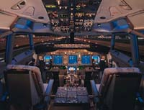
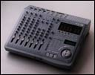
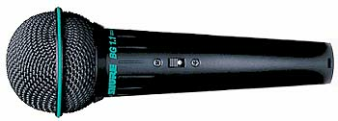

Pre-Analysis

Since SimPhonics uses a modeling approach rather than simple record/playback techniques, an analysis of the recording must be performed to identify the individual dynamic elements of the recording.

The wave spectrograph shown below illustrates a turbine engine changing RPM. Note that the frequency components are clearly identified for the individual components of the engine.

For example, the spectrograph below shows a portion of the APU startup. The turbine (discrete blade passing frequency) DPBF is clearly identified, along with some low frequency noise at the bottom of the graph.

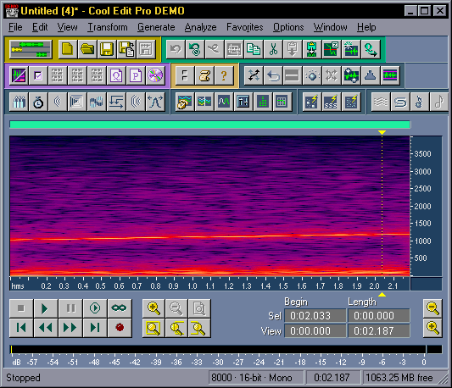

Sound Modeling/System Generation

This data will determine the dynamic amplitude versus APU RPM. Once the transfer function is determined, the curve is programmed into a VPLus design for the project, and the APU dynamics are established. The original recorded wave may be used in this case since the APU was running with no other sounds present. Otherwise, the sound would be analyzed and re-synthesized based on the data since the other sounds would have contaminated the recording.

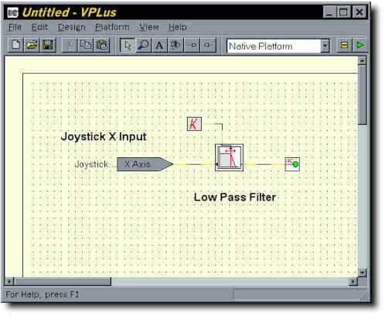
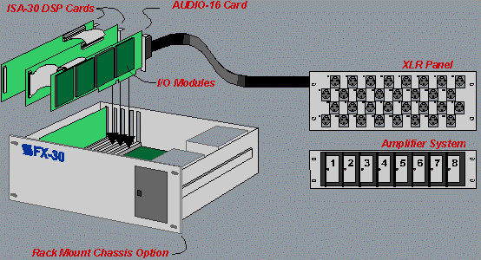

Post Analysis and Tuning

Next, the generated sound is compared to the original recording using precision third octave analysis equipment. SimPhonics uses a Brüel & Kjær Investigator™ Type 2260C monitor, and Evaluator™ Type 7820 software for this purpose. The data is stored on a laptop computer for review in a more readable form.

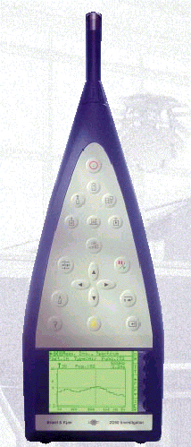
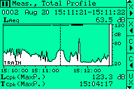
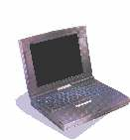

Level D Certification Tests

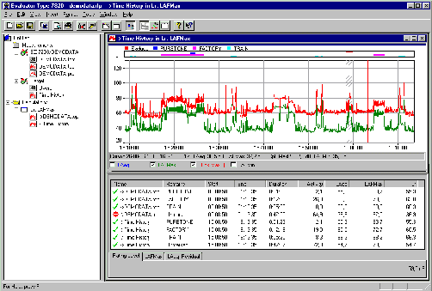
This is the last stage in the process. The original data is compared to the simulator data in a demonstrated session. The data is then reviewed with the FAA representative to conclude the test.

Further References:

U.S. Department of Transportation, Federal Aviation Administration, Advisory Circular, AC No. 120-40B

