A Beech 1900D Simulator

Using a SimPhonics Sound System

Table of Contents
1.0 Introduction 3
1.1 Document Organization 3
1.2 Referenced Documents 3
1.3 Definition of Terms 3
2.0 Concept of Operation 5
2.1 Problem Space Analysis 5
2.2 Speakers and Amplifiers 6
3.0 Data Collection 8
4.0 Sound File Editing 9
5.0 Host Computer To SimPhonics Computer Interface 10
6.0 SimPhonics Computer Configuration 11
7.0 V+ Designs 12
7.1 TopLevel Design 12
7.2 Engine Design 14
7.3 FlapsAndFuselageAero Design 16
7.4 GearAero Design 18
7.5 TireLoadAndRunwaySurfaceType Design 20
7.6 TireBlow Design 22
7.7 Weather Design 24
7.8 Windshield Design 26
7.9 Explosions Design 28
7.10 AudibleWarnings Design 29
7.11 NAV/DME Design 33
7.12 ADF Design 36
7.13 Marker Beacon Design 38
8.0 Cockpit Communications Using V+ 41
8.1 IOSCommLogic Design 43
8.2 PilotCommLogic Design 46
8.3 CoPilotCommLogic Design 47
8.4 ATIS Design 48
9.0 Afterword 54

Introduction
Hi. My name is Paul Halliday. A short while ago I was a software engineer at Training Devices International, a company that built flight simulators for cockpit training purposes. Recently, we built and delivered a Beech 1900D full-flight simulator for Aims Community College in Greeley, Colorado. It was FAA qualified at Level C, due in no small part to the sound system provided by SimPhonics, Inc. This article explains, in step-by-step detail, how the sound system is engineered for this flight simulator.

1.1 Document Organization
Section 1 provides the introduction, explains how this article is organized, cites documents referenced, and provides definitions for terms used in the article.
Section 2 describes the analysis that should be performed first when engineering a sound simulation system.
Section 3 explains how sounds are recorded for later use in the sound simulation.
Section 4 is a brief tutorial in editing sound files.
Section 5 describes how to determine the elements needed in the interface between a host computer and the SimPhonics sound computer.
Section 6 specifies the steps in configuring the SimPhonics computer.
Section 7 illustrates and describes V+ designs that are used in the Beech 1900D simulator.
Section 8 describes the cockpit communication models used in the Beech 1900D simulator.
Section 9 gives a brief synopsis of the emerging technologies at SimPhonics.

1.2 Referenced Documents
Other documents referenced in this article are as follows.
- SimPhonics’ Method of Meeting FAA Level D Sound Requirements
SimPhonics Inc., TechNotes Publication Number 3
- Custom Socket I/O Driver User Manual
SimPhonics, Inc.
- V+ Text To Speech I/O Device User Manual
SimPhonics, Inc.
- FX-30 Digital Audio System User Manual
SimPhonics, Inc.

1.3 Definition of Terms
The following glossary identifies and defines terms used in this article.
- ADI – Attitude Director Indicator.
- AGC – Automatic Gain Control.
- ASCII – American Standard Code for Information Interchange.
- ATIS – Automatic Terminal Information Service.
- BFO – Beat Frequency Oscillator.
- Binary Data – Digital sound data that is stored in binary format (i.e., a Microsoft WAVE file).
- Channel – An output route where sounds are allocated and dispatched.
- COTS – Commercial-Off-The-Shelf.
- Design – A V+ visual program constructed of objects and ports, connected via nets that are placed upon a worksheet.
- DME – Distance Measuring Equipment. This system uses a VHF radio receiver to measure the distance to a tuned navaid.
- Device – An individual sound card used in the SimPhonics sound system.
- DSP – Digital Signal Processor.
- EFIS – Electronic Flight Instrument System.
- FAA – Federal Aviation Agency.
- GPWS – Ground Proximity Warning System.
- I/O – Input/Output.
- Loop – A sample that continually repeats itself.
- LFI – Linear Function Interpolator.
- Message – An event triggered by a simulation model (e.g., a navigation radio model) and sent to the SimPhonics sound system (typically by ethernet).
- Model – Specific to this document, a model is defined as a V+ representation of an aircraft sound.
- Monaural, Mono – A method of sound reproduction whereby one or more sources are routed to a single channel.
- Navaid – Radio Navigation Aid transmitter. Provides navigation cues on various instruments in the cockpit.
- NDB – Non-Directional Beacon.
- Net – The connecting “wire” between V+ objects.
- Object – One of many V+ constructs used for implementing a design (e.g., Logical And, Logical Or, High Pass Filter, Constant Float, Looped FXDirect Player).
- ODBC – Open Database Connectivity.
- PA – Public Address.
- Panning – Varying the proportion of an audio signal between channels, typically left and right.
- Pitch – A subjective quality of a complex sound that is dependent on frequency, loudness, and intensity, most often measured by frequency. In the SimPhonics sound system, the pitch of a sound is, for all intents and purposes, its frequency.
- Port – An input/output object connecting a V+ design to real-world signals.
- Pot – Short for potentiometer. A volume control knob.
- PTT – Push-To-Talk.
- RPM – Revolutions Per Minute.
- Sample – A digitally stored representation of a sound.
- Stereophonic, Stereo – A method of sound reproduction in which two channels are used to give an illusion of a more natural distribution of sources of sound.
- TCAS – Traffic Collision Avoidance System.
- USA – United States of America.
- V+ – Object-oriented visual application development system created by SimPhonics.
- VHF – Very High Frequency. Navigation and communications radios operate in this bandwidth.
- Voice – An internal mixing channel of a sound card.
- WAVE – Windows digital audio file.
- Worksheet – A V+ window on which to place objects and ports (saved as a design file).

Concept of Operation
Whenever there is a need for a sound system in a simulator, certain steps should be followed when designing the sound system for the simulation. Understanding the problem space, identifying the aural cues, and acoustical analysis should be performed before any actual data collection/editing and acoustical engineering.
I should note here that this analysis was performed with SimPhonics already chosen as our sound simulation system. TDI chose the SimPhonics solution because of price and reputation. It is a system that is rapidly integrated into a simulator, and once the system is understood, it is readily maintained. It can be easily changed for one big reason: V+. V+ allowed us to make changes on the fly during FAA qualification. Things like changing a sound file for a particular model, reallocating the channels a sound file played on, and adding extra logic for voice communications were performed in a very short amount of time because of V+ and its ease of use. In addition, I would like to say that I prefer the SimPhonics system because it uses sound files to simulate the sounds instead of waveform generators. Sound files from the actual aircraft are always going to be more precise than waveform generators.

2.1 Problem Space Analysis
An easy way to begin understanding what the problem space is for a simulator is to identify the sources of sound in the real world. Sound sources in the Beech 1900D are as follows.
- Engines – The Beech 1900D is equipped with two Pratt & Whitney PT6A-67D turbo prop engines, one mounted on each wing.
- Warning Horns – In an aircraft, there are warning horns such as landing gear, stall, and overspeed.
- GPWS Voice Messages – The Ground Proximity Warning System provides a variety of sounds such as “PULLUP, PULLUP” and “TERAIN, TERRAIN.”
- TCAS Voice Messages – The Traffic Collision Avoidance System provides voice messages such as “DESCEND, DESCEND NOW” and “CLIMB, CLIMB NOW”.
- Navigation Radios – When tuned to a radio navigation aid, a navigation radio will play whatever is being broadcast over the carrier frequency. This is usually the Morse code identifier of the navaid. Each nav radio is considered a separate source of sound. In the Beech 1900D there are two VHF nav receivers, two DME receivers, two marker beacon receivers, and one ADF receiver.
- Communications Radios – We have a voice communications that was easily implemented by the SimPhonics sound system. In addition, we simulate an Automatic Terminal Information Service (ATIS) that provides weather information through a text-to-speech synthesizer.
- Air Impact – As an aircraft flies faster through the air, the noise of the air going over its surfaces gets louder and louder. Surfaces that produce an air impact sound that is noticeable in the cockpit typically include the windshield, the landing gear, and the flaps.
- Weather – Rain, hail, and thunder are sources of sound.
- Landing Gear – In addition to air impact noise, landing gear usually has a hydraulic motor sound, and possibly a “thunk” when locking in place (either retracted or extended).
- Flaps – Usually a flaps motor makes a sound that can be heard in the cockpit.
- Miscellaneous – Windshield wipers, cockpit ventilation, and runway rumble are sources of sound. In addition, most simulators have a crash sound to let the student know that the plane’s been broken beyond repair.
- Malfunctions – Depending on the requirements of the trainer, malfunctions can provide a rich variety of aural cues. On the Beech 1900D we have explosive decompression and tire blowouts.
Details on these sounds are provided in the Host Computer To SimPhonics Computer Interface and the V+ Designs sections of this article.
Most sources of sound within a SimPhonics system are simulated by “playing” a digital sound file (i.e., a WAVE file). SimPhonics has an extensive library of previously recorded WAVE files that can be reused for many simulations. However, each plane has a unique set of sounds that usually require an in-plane recording session to accurately capture these unique sounds. The Data Collection section of this article provides detailed information on how these sounds are captured.

2.2 Speakers and Amplifiers
After the sources of sound have been identified, an acoustical analysis of the cockpit needs to be performed. At TDI we placed speakers at locations shown in Figure 1. There are six automotive speakers and one subwoofer enclosure. Spatial orientation of the sounds and available mounting space were used for determining where the speaker should be placed. The front speakers play sounds that come from the front of the aircraft. The rear speakers are primarily used to play sounds that originate from the sides and rear of the aircraft. The Beech 1900D cockpit has overhead speakers that will play anything heard in the Pilot/CoPilot headsets if switched on. The subwoofer is used to provide extra emphasis for sounds that have low frequency harmonics (i.e., less than 100 Hz). Table 1 depicts the allocation of sound sources to the speakers.
Each speaker has its own channel of a stereo amplifier. For specifications of the speakers and amplifiers, refer to Appendix A.

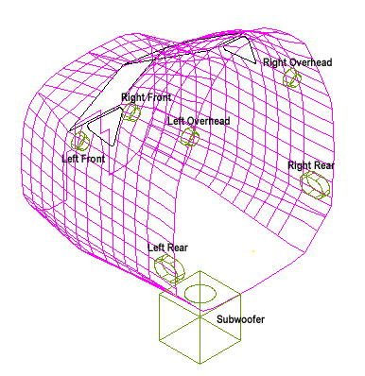
Figure 1. Beech 1900D Speaker Placement

Table 1. Sound Source to Speaker Allocation
Sound Source | Front | Rear | Overhead | Below | Pilot’s Headset | CoPilot’s Headset | Instructor’s Headset | Observer’s Headset
Engines |  | X |  | X
Warning Horns | X
GPWS | X
TCAS | X
Navigation Radios |  |  | X |  | X | X
Communications |  |  | X |  | X | X | X | X
ATIS |  |  | X |  | X | X
Air impact | X | X
Thunder, hail, rain | X | X |  | X
Flaps |  | X |  | X
Nose gear | X |  |  | X
Nose tire noises | X |  |  | X
Main gear |  | X |  | X
Main tire noises |  | X |  | X
Windshield wipers | X
Cockpit ventilation | X
Explosive decompression | X | X |  | X
Crash | X | X |  | X

Data Collection
Data collection for audio is the process of recording specific sounds needed to accurately reproduce them in a simulator. Fidelity requirements of the simulator dictate how close of a match these sounds need to be. The FAA qualified the Beech 1900D simulator at Level C, which meant that the audio had to be pretty high fidelity. Sounds such as the engines, flaps, gear, and precipitation had to be as close to the real thing as possible. SimPhonics has precipitation noises in its vast library of sounds, but the aircraft-specific sounds had to be recorded. SimPhonics collected these sounds and others (warning tones, etc.) by riding along on a flight in a Beech 1900D and recording these sounds. These recordings were made with a calibrated microphone and directly recorded to a laptop computer.
For more information regarding sound data collection and FAA qualification, refer to the SimPhonics’ Method of Meeting FAA Level D Sound Requirements TechNotes publication.

Sound File Editing
All of the sounds used in the Beech 1900D simulator are binary sound data files stored in Microsoft’s WAVE format. These data files consist of digital samplings created by either recording a live source discussed earlier, or by synthesizing them using a sound file editor. Normal editing activities can include the following.
- Trimming unwanted noise, clicks, and pops out of the data.
- Generating a sample using a tone generator.
- Converting from one format to another.
- Converting from Mono to Stereo or vice versa.
- Determining the size of the sample (8 or 16 bits).
- Cutting and pasting.
- Using Fast Fourier Transforms to isolate and filter particular sound segments within a sound.
- Matching the start and end of a sample that is going to be looped.
It is not the intent here to go into a sound file editing session. Proper treatment of such a subject would be better done in another article.
SimPhonics does not include a sound editor when delivering its systems. They recommended the Cool Edit 2000 editor, which has very good functionality at a very good price. Downloads may be evaluated and purchased at http://www.syntrillium.com.

Host Computer To SimPhonics Computer Interface
The Host Computer to SimPhonics computer interface for the Beech 1900D was implemented using SimPhonics’ Custom Socket I/O Driver. This driver is a UDP/IP socket interface that is customizable down to the bit level. Customization is done through a standard database format accessible through Open Database Connectivity (ODBC). The structure of the interface is defined using an ODBC-compatible database in the format described in SimPhonics’ Custom Socket I/O Driver User Manual. For the Beech 1900D simulator, we were given a Microsoft Access database written by SimPhonics. This database contains a table called HostBuffer, which essentially defines the data to be sent from our host to the SimPhonics computer. The HostBuffer table is mapped directly to the VPlusPorts table in a one-to-one entity relationship (we didn’t need to pack any bits to save space or bandwidth, but it can be done if necessary). The VPlusPorts table is then accessible in V+ as a list of input ports that are used in designs. A list of all of the host interface ports is obtained by clicking on the ports icon of the V+ Visual Programming System toolbar (see Figure 2). Throughout the rest of this article, these ports will be referred to as host inputs or input ports.
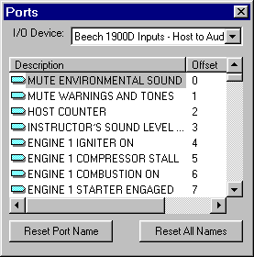
Figure 2. Host-to-Audio Ports
Our host computer is a Concurrent PowerMax PC running a real-time UNIX operating system. We needed to establish a port number for the UDP/IP socket on both the host and SimPhonics computers. This is just an arbitrary number not used by any other socket interface on either system. Once both computers were configured and running, we found some discrepancies that were fixed in relatively short order. In some cases the fix required a change to the Access database which we did using Microsoft Access 2000. In most cases changes were made on the host side to rectify the problem.
When SimPhonics populated the database, every attempt was made on their part to make use of already existing data in the host models. It was then a simple matter of defining a packet on the host side that exactly matched the description of the HostBuffer table. This packet was then transmitted across the UDP/IP socket at a 60 Hz rate.
It should be noted here that this particular interface is only one-way: from the host to the SimPhonics computer. If needed, a two-way interface could be implemented.

SimPhonics Computer Configuration
The SimPhonics computer for the Beech 1900D simulator uses three I/O devices as follows.
- Configurable Network Socket
- V+ Text to Speech Device
- FX 30 Device
The Configurable Network Socket device is what is used to set up the host interface. Refer to the Custom Socket I/O Driver User Manual for information on how to do this.
The V+ Text to Speech Device is used to produce the synthetic Airport Terminal Information Service (ATIS), discussed in the ATIS section of this article. Refer to the V+ Text To Speech I/O Device User Manual for information regarding setup of this device.
The FX 30 Device is used for the voice communications mixer, which is composed of the ISA-30 DSP and Audio 16 cards manufactured by SimPhonics. Refer to the FX-30 Digital Audio System User Manual for more information on this device.

V+ Designs
Now that we’ve identified sound sources, recorded and edited sound files, created a host computer interface, and configured the SimPhonics computer, “How do we make it all work?” you may ask. V+ is the answer. V+ is a visual application development system that replaces text-based programming. This is what is used to tie the host computer’s stimuli to the sounds to be played and the voice communications to be mixed.
A V+ design is captured in what is called a worksheet design file. It is very much like a logic circuit diagram, with inputs, logic, and outputs. With V+, you can create as many worksheets as you feel are needed to accurately represent your sound system design. On the Beech 1900D, there are 19 worksheet design files that are used to simulate the sounds of the aircraft. We will go into detail on each on of these in the following sections. These design files contain models implemented with V+ that represent real-world sounds. While these models are specific to the Beech 1900D, they could easily lend themselves to models for another aircraft type, or for that matter, another vehicle type, such as a tank. Sound files and V+ logic would have to be changed, but the basic design could remain intact.
In the following sections, a lot of attention is paid to Linear Float Interpolators (LFIs). These are in-line look-up tables that greatly affect how a sound is played (usually through volume and/or frequency changes). Each table is presented as a V+ figure displaying a curve, which represents the interpolation data. It is not the intent of this article go into the mathematical substance of these data, but rather to give the reader an idea of what the curve looks like.

7.1 TopLevel Design
The best place to start is with the top-level functionality. This typically involves dealing with the host computer’s frame counter and the instructor’s volume controls. Figure 3 contains the TopLevel worksheet file for the Beech 1900D. Shown here are six input ports that are found in the VPlusPorts table described in the Host Computer To SimPhonics Computer Interface section. The six input ports are described as follows.
- Host Counter – Host computer’s frame counter. Should be incremented at a rate of at least 30 Hz.
- Mute Warnings & Tones – Used to mute GPWS, TCAS, warning horns, and nav tones.
- Mute Environmental Sound – Mutes all environment sounds (i.e., engines, air impact, weather, flaps, landing gear, tires, runway rumble, windshield wipers, cockpit ventilation, and explosive decompression).
- Instructor’s Sound Level Control – Variable volume range for setting the volume of the environmental sounds.
- Ground Speed – Speed of the aircraft along the ground.
- Air Impact Pressure – Speed of the air against the aircraft.
The Host Counter input port is connected directly to a Watch Dog Timer with a timeout value set to 10. If the Host Counter fails to update within 10 V+ frames, the Watch Dog Timer will go high, causing the Master Volume and Warnings & Tones Volume to go to zero.
At the top left of the worksheet is a constant tied directly to the Global Switch Control object. This acts as the Manual/Host Control Switch. The rest of the worksheets monitor this switch for debugging purposes. When the Global Switch Control is on, the switch monitors may set their own values to be used for testing or debugging. See the help page on the Global Switch Control for more information.
On the Beech 1900D, we divided all of the sounds into two groups: Environmental and Warning & Tones. Environmental sounds come from the engines, control surfaces, wind, etc. Warnings & Tones are the sounds that are specifically generated to capture the pilots’ attention. Master volume control is separate for both of these groups. The output of the Watch Dog Timer, and input items 2, 3, and 4 identified above are used to set the worksheet connectors Master Volume and Warnings & Tones Volume shown at the right of the TopLevel worksheet. The output of the Watch Dog Timer is fed into a Logical And object, which is then fed into a Logical Or object, which is then inverted and fed into a First Order Low Pass Filter, which is fed into a Float Linear Function Interpolator (LFI), and finally finds its way to the worksheet connectors. The outcome of all this is to provide a master volume value to be used by all the WAVE file players in the system. You’ll see how this works in subsequent worksheet designs.
Let’s take a closer look at the Soft Mute Integrators shown on the worksheet. They use a low pass filter and an LFI to affect the decay and attack characteristics of the sounds that are playing when a mute/unmute is issued by the host. The effect is such that a gradual shut-off and a gradual ramp-up of the sounds. This is especially nice after coming out of a simulation freeze – it keeps from abruptly startling people in the simulator.
The Ground Speed and Air Impact Pressure input ports are wired directly into worksheet connectors. We placed them in the TopLevel worksheet since there are several other worksheets that use them as input.

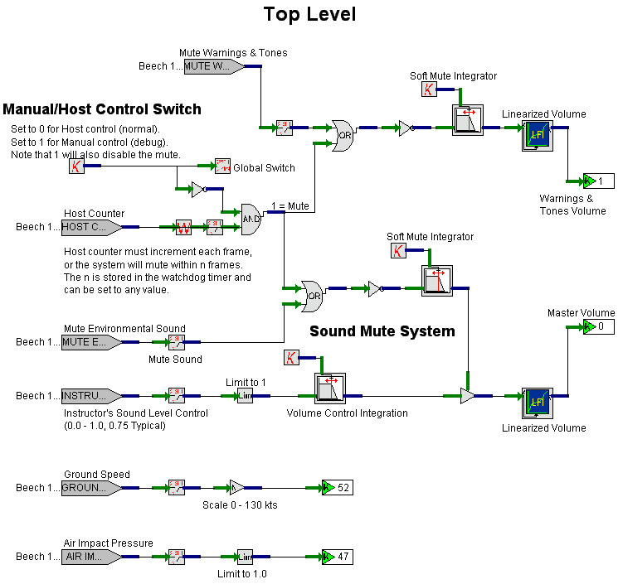
Figure 3. TopLevel Design

7.2 Engine Design
There are two engine worksheets that are used to simulate the two engines for the Beech 1900D. Figure 9 depicts the worksheet for Engine1. The worksheet for Engine2 differs only in the input ports and channel allocations for the Looped DirectFX Players. The inputs to Engine1 are as follows.
- Air Impact Pressure – Worksheet connector from TopLevel.
- Engine 1 Prop Blade Angle – Propeller blade angle measured in degrees.
- Engine 1 Prop Torque – Propeller torque for Engine 1 measured in foot-pounds.
- Engine 1 Turbine RPM – Turbine revolutions measured as a percentage of maximum power.
On a turbo-prop engine such as the Pratt & Whitney PT6A-67D, the sound that is heard comes primarily from the noise of the propellers slicing through the air. In the Engine1 design, two WAVE files are played. The first is a looped sample of the engine at full pitch. The second is a looped sample of the engine at full feather. Four Looped DirectFX Players are used. The first pair, labeled Rear Speakers, plays on the rear speakers with the balance mostly skewed to the left (Engine2’s rear speaker players are skewed mostly to the right). The second pair plays on the sub-woofer to add low frequency rumble. There are four inputs to a Looped DirectFX Player: Volume, Frequency, Balance, and Enable. The Balance is fixed as per the skew discussed earlier. The Enable is always activated. The Volume and Frequency inputs are variable based on the discussion that follows.
The Volume input for the full pitch sound is a function of Air Impact Pressure, Propeller Blade Angle, Propeller Torque, and Turbine RPM. Each of these inputs runs through a Float LFI. Each of these LFIs becomes a multiplier to determine the final volume provided as input to the player. The LFI for Air Impact Pressure, shown in Figure 4, is a curve that has little effect, but slowly decreases the output as air impact increases. The Propeller Blade Angle LFI, Figure 5, is a curve that rapidly increases and levels out as blade angle is increased. Figure 6 contains the Propeller Torque LFI, which is a curve that has little effect, but slowly increases as torque increases. The LFI for Turbine RPM, Figure 7, is a curve that creates a good amount of gain as RPM increases.
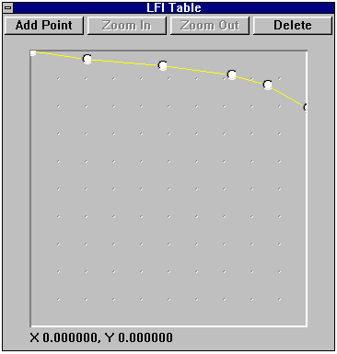 | 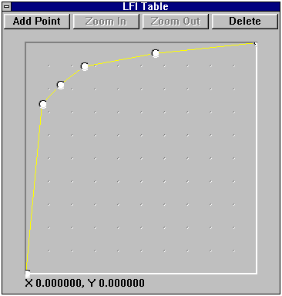
Figure 4. LFI for Air Impact Pressure on Engine Volume | Figure 5. LFI for Prop Blade Angle on Engine Volume for Full Pitch Sound

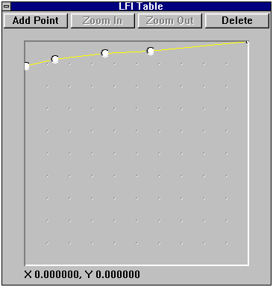 | 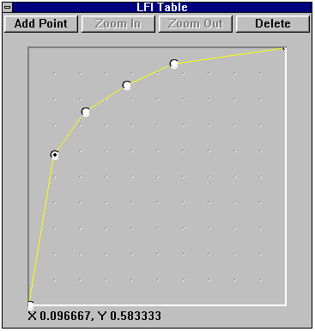 | 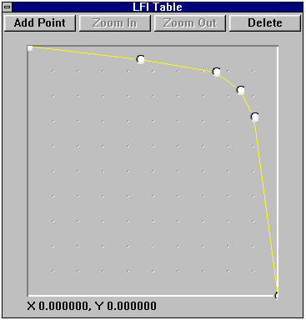
Figure 6. LFI for Propeller Torque on Engine Volume | Figure 7. LFI for Turbine RPM on Engine Volume | Figure 8. LFI for Prop Blade Angle on Engine Volume for Full Feather Sound
The Volume input for the full feather sound is also function of Air Impact Pressure, Propeller Blade Angle, Propeller Torque, and Turbine RPM. The only difference between this “equation” and the one for the full pitch sound is that the LFI for Propeller Blade Angle is inverted, as shown in Figure 8. In other words, as blade angle increases, the output value decreases. Compare this curve with the one in Figure 5.
The Frequency for both the full pitch and full feather sounds is directly affected by the Turbine RPM input. As the RPM percentage is increased, so is the frequency. A First Order Low Pass Filter is used to smooth the change in frequency, which gets rid of any abrupt changes that might come from the Host Computer.
At the bottom of the Engine1 worksheet is a model called Engine 1 Compressor Stall. This is a pretty simple model that simulates a turbine compressor stall, much like a backfire on your car. It has two one-shot players: one for the rear speakers, and one for the sub-woofer (a One-Shot FXDirect Player only plays through the sound once). The volume, frequency, and balance pins for these players are fixed constants. The enable pins are hooked to the Compressor Stall Engine 1 input port, which is commonly implemented at the host computer as a malfunction.
Note that the Master Volume worksheet connector goes to a Multiply Float object, which has final control of the volume for all the players in this worksheet. This will be the case in subsequent design discussions, and consequently, not mentioned again. Also note that a Multiply By Static Data Constant object labeled VOL Trim precedes the Master Volume multiplier. This allows for fine-tuning of the volume setting for a given player. All players in subsequent designs have a VOL Trim “pot”, so again, no need to mention them anymore.
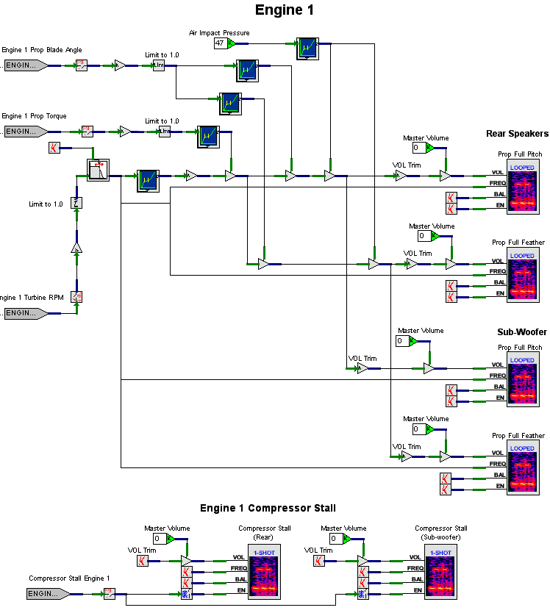
Figure 9. Engine1 Design

7.3 FlapsAndFuselageAero Design
The design for the FlapsAndFuselageAero is shown in Figure 15. This worksheet models sounds for air impact on the fuselage, air impact on the flaps, and the flaps motor. We’ll discuss each of these models separately.
The Fuselage - Air Impact model has one input and two players. The players play the same sound on the front speakers and the rear speakers. The balance and enable inputs are constantly 0 and 1 respectively. The input Air Impact Pressure is passed through a First Order Low Pass Filter, which then splits into two paths for volume and frequency. The low pass filter is used to smooth any abrupt changes in air impact.
Let’s analyze what sound effects occur as an aircraft’s nose passes through air. As the air impact increases, the sound of the wind passing over the windscreen increases in volume, while its pitch also increases. The volume path for both players passes through a Float LFI. As shown in Figure 10, the volume starts at 0, rapidly increases, and then begins to level out to a maximum of 100%.
The frequency path for both players goes through a Float LFI, Figure 11, that starts at about 60%, and gradually increases to 100% as the air impact increases.
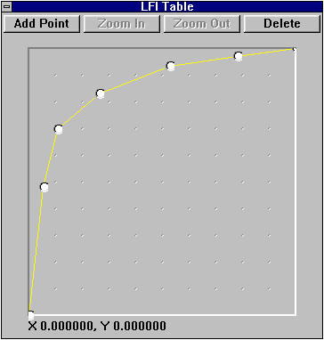 | 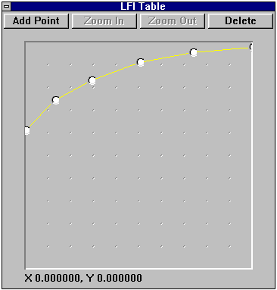
Figure 10. LFI for Fuselage Air Impact Volume | Figure 11. LFI for Fuselage Air Impact Frequency
The Flaps - Air Impact model has two inputs and two players. The players play the same sound on the rear speakers and the sub-woofer. The balance and enable inputs are constantly 0 and 1 respectively. The Flaps Position input passes through a First Order Low Pass Filter, which then splits into two paths for volume and frequency. Volume for the players is a function of air impact and flaps position. Air impact if fed to the LFI shown in Figure 12, whose curve starts at 0 and increases to 1. Figure 13 is the LFI for the flaps position that feeds the volume. The curve starts at 0, rapidly increases, and levels out to a maximum of 1.
The frequency for the players is a function of flaps position only. This is passed to the LFI shown in Figure 14. Note that as the flaps surface increases, the frequency is lowered. This, coupled with playing the sound on the sub-woofer, gives a very low frequency noise rumble when flaps position and speed is increased. It will, in fact, begin to rattle the cockpit if taken to the extreme.
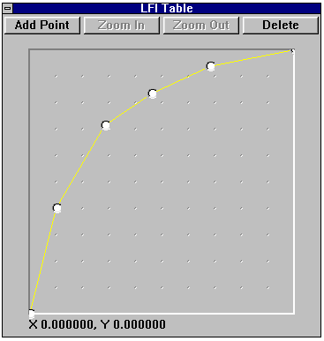 | 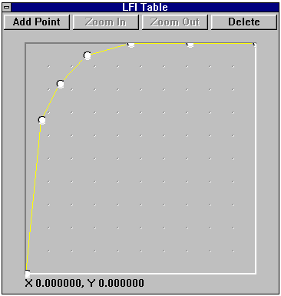 | 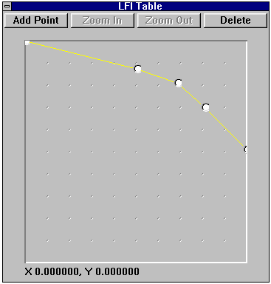
Figure 12. LFI for Air Impact on Flaps Volume | Figure 13. LFI for Flaps Position Volume | Figure 14. LFI for Flaps Position Frequency
The Flaps – Motor Sound model has one input and one player. The player plays the motor sound on the rear speakers. The frequency, balance, and enable inputs are constantly 1, 0, and 1 respectively. The flaps position input passes through a First Order High Pass Filter, which is then multiplied by the flaps position input to produce an output as long as the flaps position is changing. A First Order Low Pass Filter is then used to smooth out any abrupt changes in flaps position coming from the host computer. The output of the low pass filter is then provided as volume input to the flaps motor sound player.
9
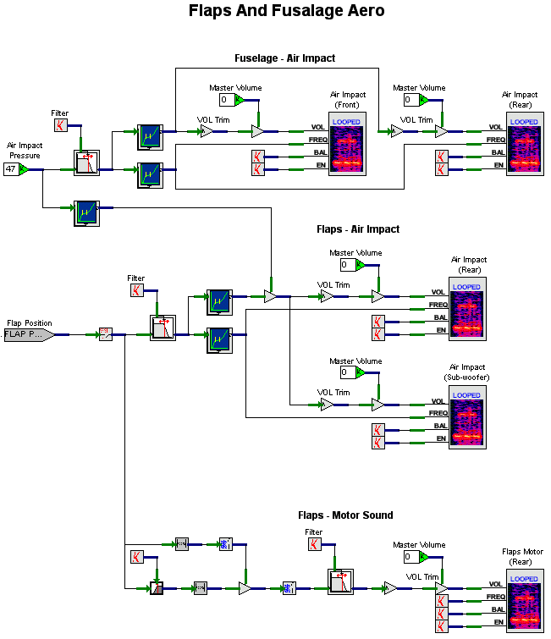
Figure 15. FlapsAndFuselageAero Design

7.4 GearAero Design
There are four models in the GearAero worksheet. The first three, Nose Gear – Air Impact, Right Main Gear – Air Impact, and Left Main Gear – Air Impact, deal with the air impact on the nose, left main, and right main landing gear. For the most part, these models are the same. They differ in that they each have their own specific input for gear position. They each have two players for the air impact sound, one for the rear speakers and one for the sub-woofer. Each of the players has the balance and enable inputs set to 0 and 1 respectively. The volume for the players is a function of air impact pressure and gear position. Figure 16 contains the LFI for air impact’s effect on volume for all three models. The curve starts at 0, rapidly rises and levels off at 1. The gear position input passes through a Low Pass Filter whose output is split between the volume path and the frequency path. Along the volume path, it goes through the LFI shown in Figure 17. This curve also starts at 0 and rapidly rises and levels out at 1. This makes sense. As more of a landing gear strut is exposed to the air, the volume of air rushing past it increases, and as the speed of the strut flying through the air increases, the volume of air rushing past it also increases.
The frequency for the air impact player is a function of gear position only. As more of the gear strut is exposed, it lowers the frequency of the air impact noise (similar to the flaps frequency), as is shown in Figure 18.
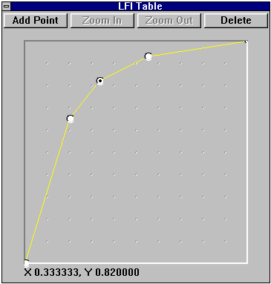 | 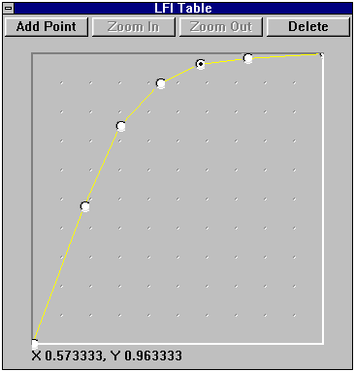 | 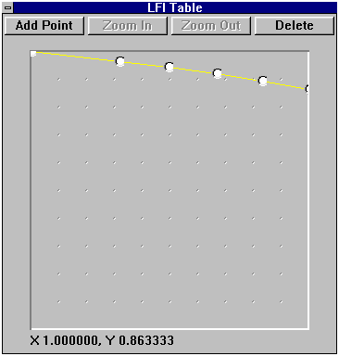
Figure 16. LFI for Air Impact on Volume | Figure 17. LFI for Gear Position on Volume | Figure 18. LFI for Gear Position on Frequency

The Gear – Motor Sound model is shown at the bottom of Figure 19. In the Beech 1900D, all of the gear extend and retract at the same rate. Since this motor sound is barely heard in the cockpit, we felt that it only needed to be attached to one of the gear struts. There are two players for this model: one for the rear speakers and one for the sub-woofer. The frequency, balance, and enable inputs are constantly 1, 0, and 1 respectively. The gear position input passes through a High Pass Filter, which is then multiplied by the gear position input to produce an output as long as the gear position is changing. A Low Pass Filter is then used to smooth out any abrupt changes in gear position coming from the host computer. The output of the low pass filter is then provided as volume input to the gear motor sound player.
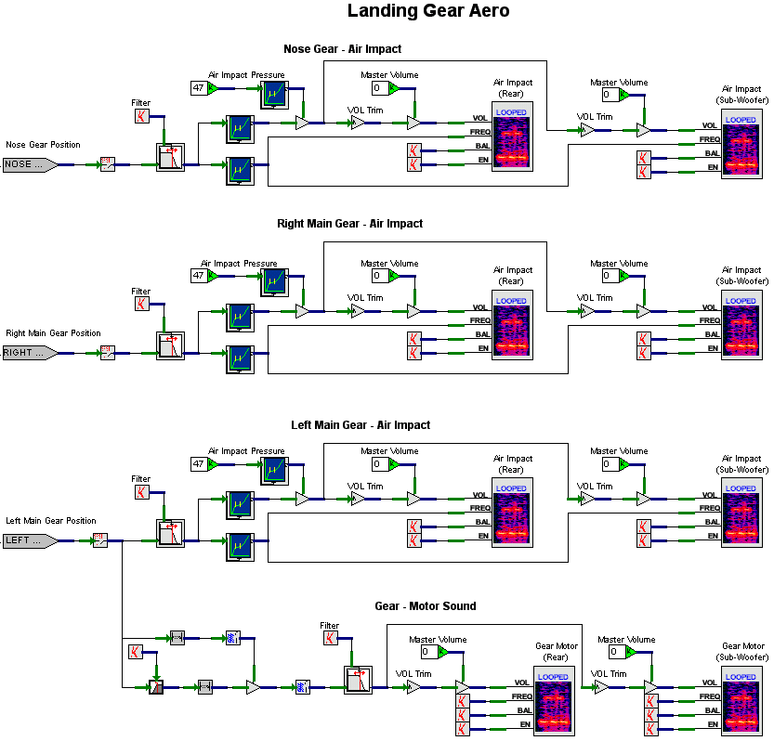
Figure 19. GearAero Design

TireLoadAndRunwaySurfaceType Design
There are four models in the TireLoadAndRunwaySurfaceType worksheet, shown in Figure 23. The output of the first, Runway Amplitude, is used in the next three: Nose Tire, Left Tire, and Right Tire.
The Runway Amplitude model’s purpose is to take an enumerated type passed in through the Runway Surface Type port, and covert it to a value normalized between 0.0 and 1.0. The input is limited to 4 and then passed to a One of Eight Selector object. The One of Eight Selector accepts an input value of zero to seven and produces an output of 1.0 on the respective output pin. The pin on the top right is the 0 pin, and the pin on the bottom right is the 7 pin. There are five possible input values that can be passed in. These values and their respective meanings are provided in Table 2. Only the first five output pins of the selector are used. The others are shunted to No Connection objects. Pins 0 through 4 are each passed into a Multiply by Static Data Constant object, which essentially converts the enumerated value into the normalized value shown in column four of Table 2. These values are then passed to the worksheet connector called Runway Amp. The values are summed together using Sum Float objects. The reason for this is to take five lines and merge them into one.
Table 2. Runway Surface Type Conversion
Input Value | Input Value  Meaning | Output Pin | Converted Value
0 | Invalid, Unknown | 0 | 0.00
1 | Hard Smooth Surface | 1 | 0.80
2 | Hard Rough Surface | 2 | 0.85
3 | Soft Smooth Surface | 3 | 0.90
4 | Soft Rough Surface | 4 | 1.00

The three tire models are essentially the same, differing only with their primary inputs. Each of these inputs is a gear loading value associated with the respective tire. Each of the players is allocated to the sub-woofer channel (hence the constant for the balance input). Each of the players enable pin is a constant 1 since a zero volume will effectively turn the player off.
Volume for the three players is a function of ground speed, gear load and runway amplitude. Each of these inputs passes through an LFI. The LFI for ground speed is shown in Figure 20 and the LFI for gear load is shown in Figure 21. The curve for ground speed starts at 0 and increases toward a value of 1. Note that the curve for gear load rises immediately and levels off at 1. This makes sense, since there is no noise without any gear load.
The frequency for these players is only a function of gear load. As the gear load increase, so does the frequency. The input is passed through the LFI shown in Figure 22. The curve starts at about 40% and rises to a final value of 100%. Gear load is actually pretty instantaneous, so the frequency and volume LFIs associated with it will almost always be 100%.

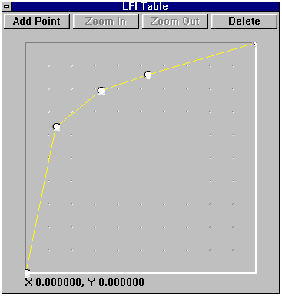 | 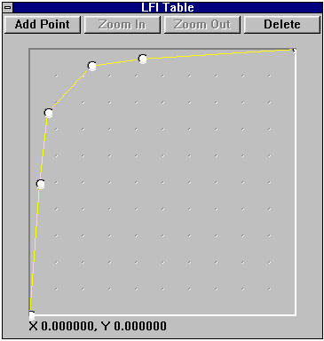 | 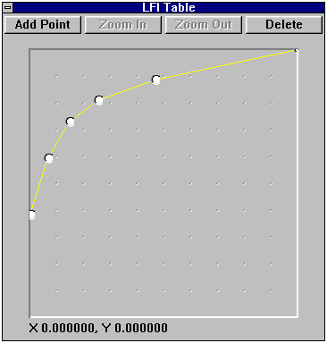
Figure 20. LFI for Ground Speed on Tire Rolling Volume | Figure 21. LFI for Gear Load on Tire Rolling Volume | Figure 22. LFI for Gear Load on Tire Rolling Frequency

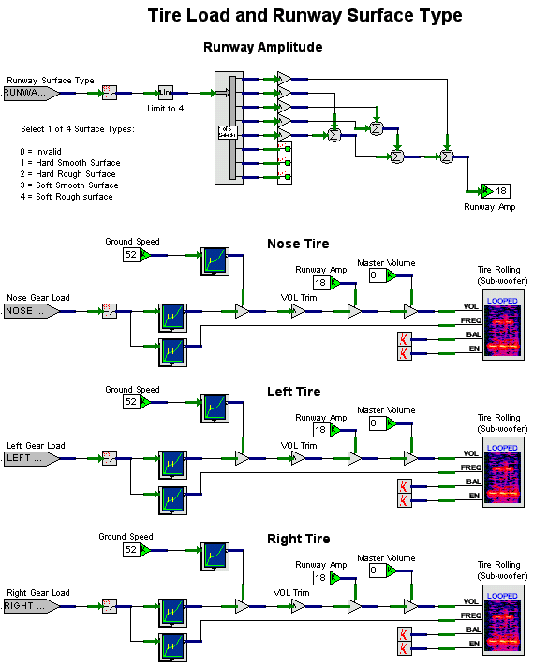
Figure 23. TireLoadAndRunwaySurfaceType Design

TireBlow Design
The TireBlow design produces sounds for when a tire blow malfunction is triggered at the instructor station. There are three models in the TireBlow worksheet, one for each of the tires (Figure 25). Each of these models is similar with the only difference being the inputs.
A tire blow is composed of two distinct sounds. The first is the explosion, and the second is the sound the tire makes as it deflates and rolls down the runway (if you can call it rolling). The tire blow players are one-shot players. These players’ enable pin is hooked up to the tire blow input. The volume, frequency, and balance pins are hooked to constants, as there is no variance in these characteristics. There are two players for the tire blow sound, one that is allocated to the sub-woofer, and one that is allocated to the rear speakers. One might think that the nose tire should be allocated to the front speakers instead of the rear. However, the nose gear is actually right under the cockpit, and sending them to the rear speakers provides a more realistic spatial cue than if it was played on the front speakers.
The flat tire sound is played on a looped player that is enabled as long as the malfunction is on. The sound only plays on the rear speakers, as it probably would not be heard on the sub-woofer. The balance input for the player is a fixed constant of 0. The volume is a function of the tire blow input that is run through a low pass filter to simulate a deflation delay. The frequency is a function of ground speed passed through an LFI shown in Figure 24. The curve for the LFI starts at 0, and rapidly ramps up and levels off at 1.

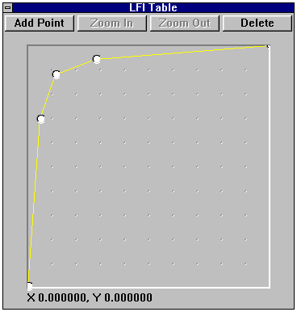
Figure 24. LFI for Tire Blow Frequency

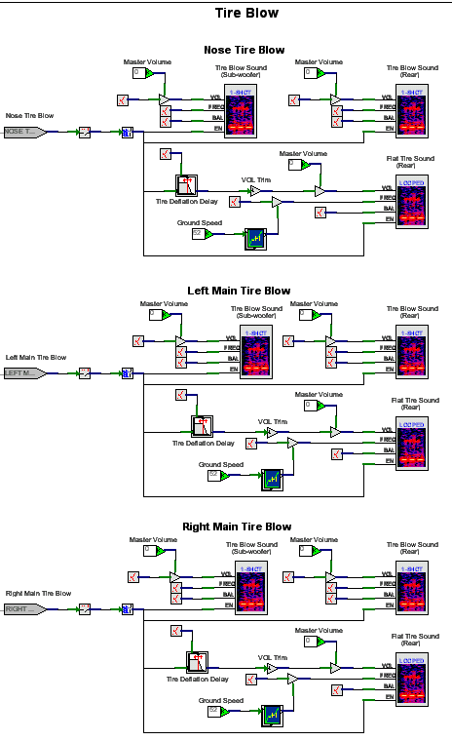
Figure 25. TireBlow Design

7.7 Weather Design
The Weather worksheet, Figure 28, has three models in it: Thunder, Rain, and Hail. The Thunder model is pretty simple. It has two players, one for the rear speakers, and one for the sub-woofer. The frequency, balance, and enable pins are hard-coded constants. The volume for the players is turned to maximum when the thunder input is turned on at the host. Pretty simple, huh? The WAVE file that is played is a pretty long one that continues to repeat, giving it the “appearance” of random thunder.
The Rain and Hail models are the same except for the inputs that they receive, and the WAVE files that they play. They both have two looped players, one for the front speakers, and one for the rear speakers (using the sub-woofer would have no effect as these sound files have a frequency domain higher than the sub-woofer could play). The balance and enable input pins for the players are constants.
The volume for these players is a function of rain/hail intensity. These inputs go to a low pass filter which smoothes any abrupt changes coming from the host. The output of the low pass filter is then fed to the LFI shown in Figure 26. The curve shows us that it’s going to get loud pretty quick.
The frequency for the players is a function of air impact pressure. As the air impact increases, so does the frequency, as shown in Figure 27. This makes sense, doesn’t it? Take for instance driving in your car while it’s raining moderately. When you come to a stop, there’s not much noise from the rain or hail hitting your windshield. When you’re going say 50 mph, more rain or hail is going to hit your windshield.

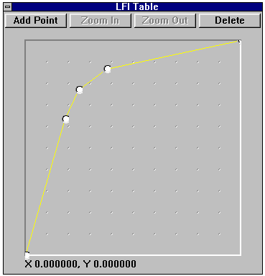 | 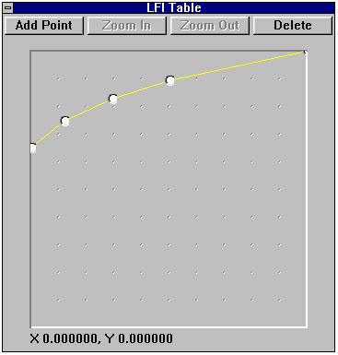
Figure 26. LFI for Rain/Hail Volume | Figure 27. LFI for Air Impact on  Rain/Hail Frequency

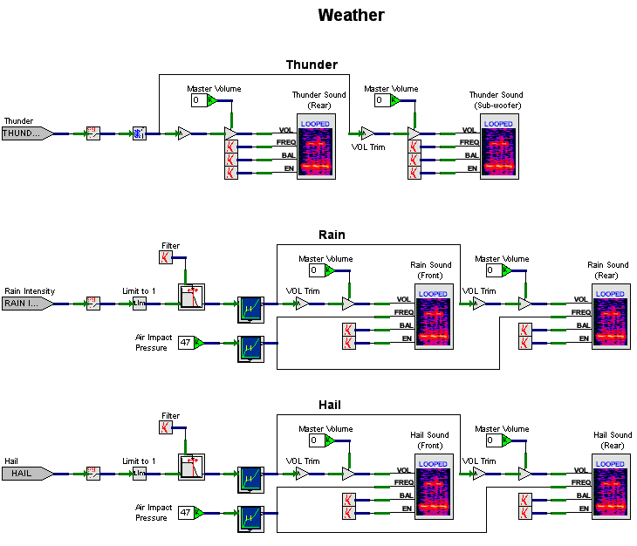
Figure 28. Weather Design

7.8 Windshield Design
The Windshield design contains three models: Left Windshield Wiper, Right Windshield Wiper, and Windshield Defrost. Figure 33 depicts the worksheet for this design.
The wiper models are similar and differ only by their inputs and which channel of the front speakers the sound plays on (Left Windshield Wiper plays on the left channel, Right Windshield Wiper plays on the right). The volume for the wiper sound is a function of the wiper speed input. The input passes through an LFI shown in Figure 29. The curve shows that it increases in volume rapidly and levels off to 1.
The frequency for the wiper sound is also a function of wiper speed. It passes through the LFI shown in Figure 30. This is what is called a step-function. On the Beech 1900D, there are two wiper speeds: slow and fast. When our host computer sends over the wiper speed, it uses 50% for slow speed and 100% for fast. Note that the step occurs at about 60%, which provides a little cushion past the slow speed mark. The output of the frequency LFI is sent through a low pass filter, which ramps the speed change to simulate the mechanical limitations of the wiper system (wipers don’t instantly change speed).
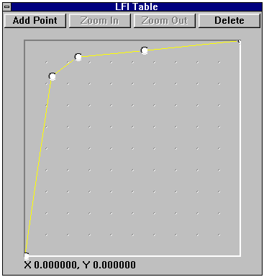 | 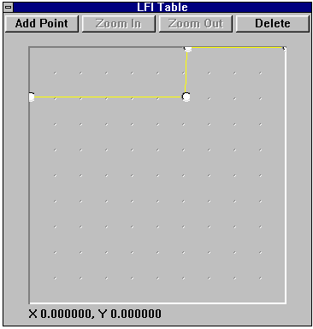
Figure 29. LFI for Wiper Speed on Wiper Volume | Figure 30. LFI for Wiper Speed on Wiper Frequency

The Windshield Defrost model is relatively simple. It accepts an input form the host called Windshield Defrost On, which is a simple toggle. The input is sent through a Float to BOOL object, and passed along to a low pass filter, which is used to smooth any abrupt changes coming from the host. The output of the low pass filter is then split into the volume and frequency paths for the player. The player plays the sound on the front speakers. The enable pin of the player is hooked directly to the Float to BOOL The balance pin is a constant allocated to both channels.
The volume is a function of the Defrost On input. It uses an LFI shown in Figure 31. The curve for this LFI starts at 0, then rises at a good rate and levels off at 1.
The frequency is also a function of the Defrost On input. It uses the LFI shown in Figure 32. This curve starts at about 55% and gradually rises to 100%.
The Windshield Defrost model is actually designed to be more sophisticated than is needed by our simulator. In the Beech 1900D, the windshield defrost is either on or off. If the input was a variable range to simulate multiple defrost fan speeds, we could make some simple changes to the model to accommodate a range. All we would have to do is move the Float to BOOL to be used only by the enable pin. This would then actually make complete use of the LFIs for volume and frequency.

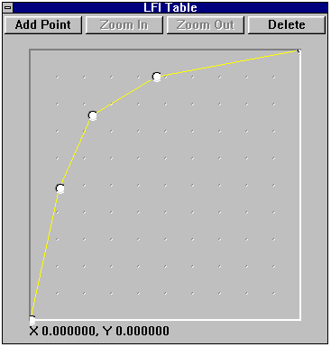 | 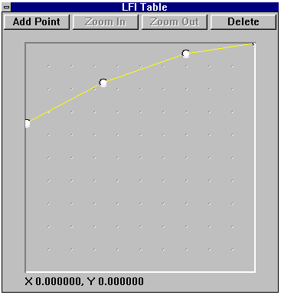
Figure 31. LFI for Windshield Defrost Volume | Figure 32. LFI for Windshield Defrost Frequency
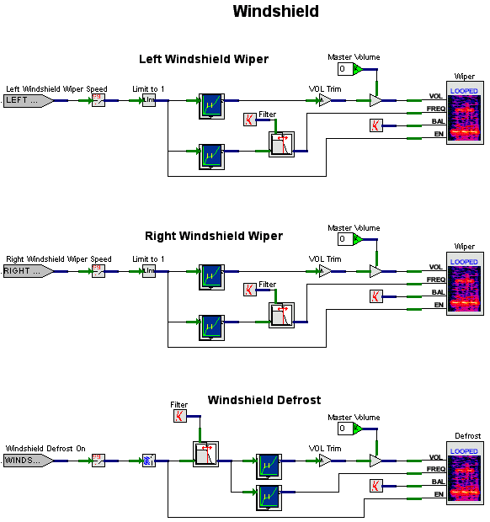
Figure 33. Windshield Design

7.9 Explosions Design
The Explosions design has a couple of models that don’t seem to fit anywhere else: Crash and Explosive Decompression. The worksheet is presented in Figure 35. These models are fun to activate, especially when you can catch people off guard. You just have to be careful not to give anybody a heart attack.
The Crash model is really simple. It uses three players to play on front, rear, and sub-woofer speakers. There is a single input coming from the host: a crash indication usually generated by a flight model. When this model is activated, it really gets everybody’s attention.
The Explosive Decompression model is a little more complicated. A malfunction trigger at the host called Explosive Decompression activates the model. This input is tied to the enable pins of two players, one for the rear speakers, and one for the sub-woofer. The frequency and balance pins are hard-coded constants.
The volume for the players is a function of an input called Differential Pressure. This input goes through the LFI shown in Figure 34. The higher the differential pressure, the louder the explosion.

Figure 34. LFI for Differential Pressure on
Explosive Decompression Volume

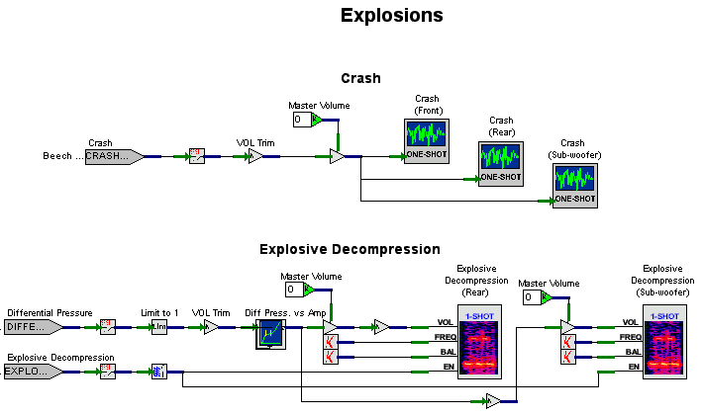
Figure 35. Explosions Design

AudibleWarnings Design
The worksheet for AudibleWarnings is a big one with many models in it. The total worksheet is too big to display in one figure, so I divided into three figures. Figure 36 contains models for the Ground Proximity Warning System (GPWS). Figure 37 contains more GPWS models. Figure 38 contains miscellaneous models for the following.
- Traffic Collision Avoidance System (TCAS) voice messages
- Altitude alert warning
- Decision height warning
- Overspeed warning
- Stall warning
- Landing gear warning
- EFIS auxiliary warning
- Standby ADI auxiliary warning
Each of the models, except as noted below, has an input from the host and either a One-Shot or Looped player. Most of the players are looped because the warning message continues until the host trigger turns it off.
There are two slightly more complicated models: GPWS TERRAIN PULLUP and GPWS NORMAL SELF TEST. These voice messages are composed of two different WAVE files. The One-Shot object plays the first part of the message, and the Looped object plays and repeats the second part of the voice message after a delay, specified by the On Delay object.
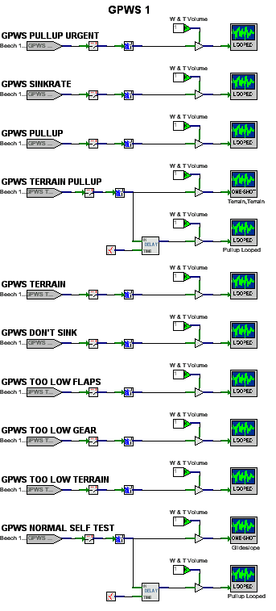
Figure 36. AudibleWarnings Design (GPWS)
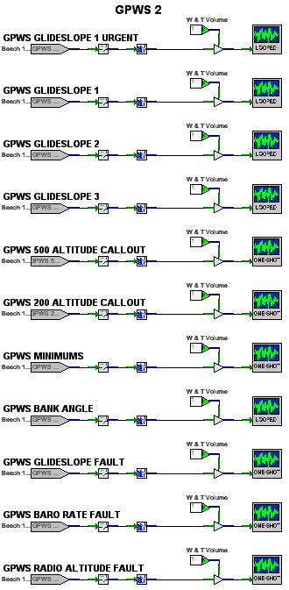
Figure 37. AudibleWarnings Design (GPWS cont’d)
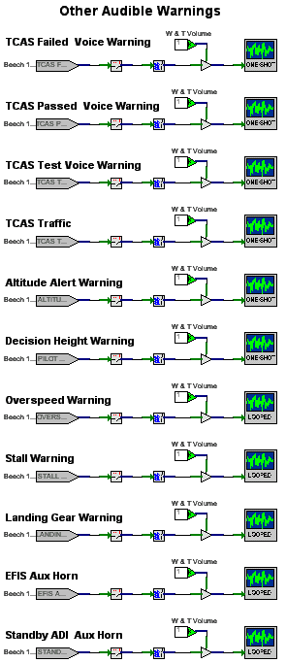
Figure 38. AudibleWarnings Design (miscellaneous)

7.11 NAV/DME Design
There are two NAV/DME worksheets. NAV_DME_1 contains models for the first set of VHF (commonly referred to as NAV) and DME navigation radio receivers. NAV_DME_2 contains the same models for the second set. The worksheets only differ by the inputs they accept from the host (NAV 1 versus NAV 2, etc). For purposes of this discussion, we’ll only talk about the NAV_DME_1 worksheet. I’ve split the worksheet into two figures: the Plot’s section (Figure 40) and the CoPilot’s section (Figure 41). We’ll discuss the Pilot’s section first.
There are 14 host inputs and 5 players for this design. The inputs labeled Pilot Audio NAV 1 and Pilot Audio DME 1 are switches on the cockpit’s audio panel that allow the pilot to selectively listen to the NAV 1 or DME 1 radio signals. These eventually tie into the volume for the players. The NAV 1 and DME 1 Receiver Master Volume inputs are volume control knobs on the radio heads. The NAV 1 and DME 1 Signal-to-Noise Ratio inputs are signal strength ratios calculated by the host computer’s radio models. These inputs are fed into an Automatic Gain Control (AGC) mini-model. This mini-model employs a High Pass Filter object and a Sum Float object to only produce a value when the Signal-to-Noise ratio is changing. The output of the AGC is then limited to 1 and is split into two paths. The first path goes to the Radio Noise player volume pin. Before it gets there, it is subtracted from a constant 1.0 which will give us the noise portion of the Signal-to-Noise ratio (the sum of the signal and the noise will always equal 1.0). The second path is combined with the output of a NAV/DME Keyer object, which is explained in the following paragraph.
The group of eight inputs labeled NAV1/DME1 Ident Letters represents character inputs of four identification letters each for the NAV 1 transmitter and the DME 1 transmitter. These are fed into the NAV/DME Keyer. This keyer translates the letters into Morse Code pulses, which are eventually fed into the NAV and DME tone players.
The 30Hz Modulation player represents a pair 30Hz sine waves on the VOR carrier that are out of phase with each other. These waves are used by the receiver to determine the azimuth to the station, which is then provided to an indicator of some sort (usually a Horizontal Situation Indicator). Since 30Hz is effectively inaudible, what we hear are the harmonics of the modulation, which is kind of a clicking noise.
Note that all of the players of this design have fixed constants that feed the frequency, balance, and enable pins. There is no need to dynamically change these attributes of the players.
You may have noticed that there are five LFIs in this model, which are tied into the volume pins of the players. These are used to linearize the volume of a signal, which is a logarithmic DB volume. The curve for all of these LFIs is the same and is shown in Figure 39.
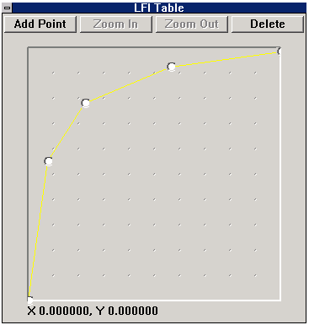
Figure 39. LFI for Volume Control of NAV/DME Tones
The CoPilot section of this design is largely dependent on the modeling performed in the Pilot portion. Worksheet connectors are used to take advantage of modeling something only once.
I know this is a confusing model – it’s taken me about six months to get a grip on it. However, it’s probably the most accurate audio radio model in the business because it incorporates subtleties not normally heard in most simulators. The beauty of this model is that it’s already done, and can be reused on any simulator that has a VOR/DME radio system.

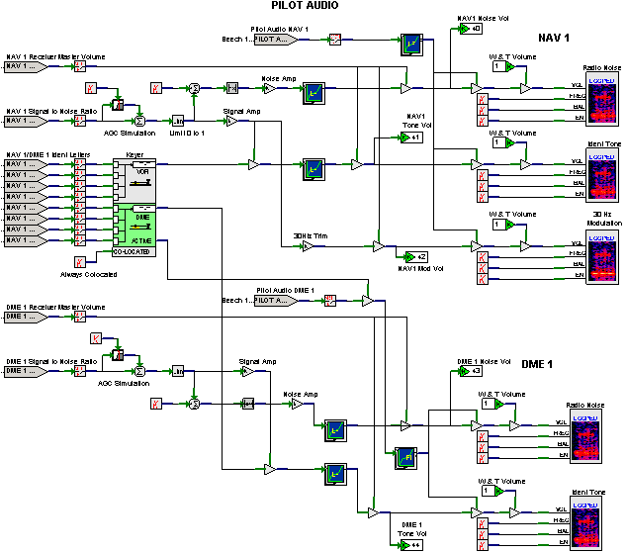
Figure 40. NAV_DME_1 Design (Pilot)

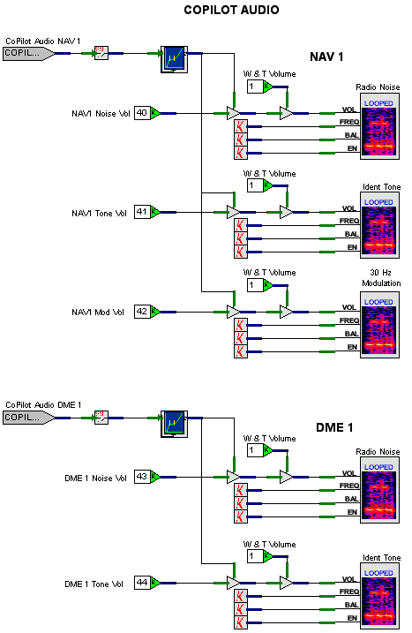
Figure 41. NAV_DME_1 Design (CoPilot)

7.12 ADF Design
This design is very similar to the NAV/DME design. Again I’ve split it up into two sections: Pilot and CoPilot. Let’s discuss the Pilots’s section first.
There are nine inputs from the host and three players. The Pilot Audio ADF input is a switch on the n the cockpit’s audio panel that allow the pilot to selectively listen to the ADF radio. This switch is combined with any signal going to a player’s volume pin. The ADF’s master volume input is also combined with any signal going to a player’s volume pin. There are four inputs grouped under the label ADF 1 Ident Letters. These inputs represent the four-character ADF station identifier. They are fed into an ADF Keyer object, which generates the Morse Code pulses for the Ident Tone player.
The ADF 1 Freq Diff and ADF 1 BFO On inputs are used to model a Beat Frequency Oscillator. This has to do with older NDB transmitters use keyed carrier waves. Very few of these are left in existence, and most modern-day ADF receivers have phased-locked tuning, eliminating the need for using these controls to properly tune the ADF radio. The Beech 1900D didn’t need to use this capability, but I left it in anyway because it shows how robust this model is.
As was the case with the NAV/DME design, all of the players in the ADF design have fixed constants that feed the frequency, balance, and enable pins. Again, there is no need to dynamically change these attributes of the players.
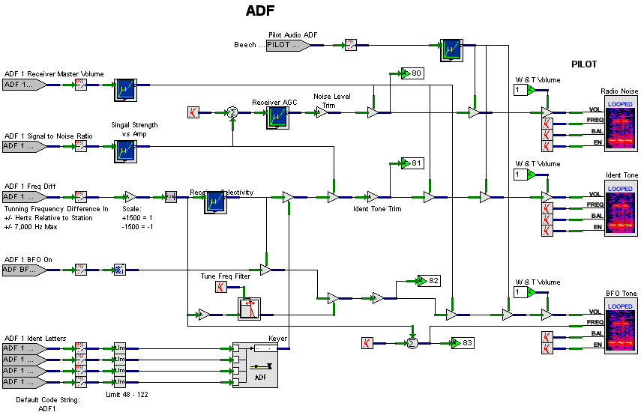
Figure 42. ADF Design (Pilot)

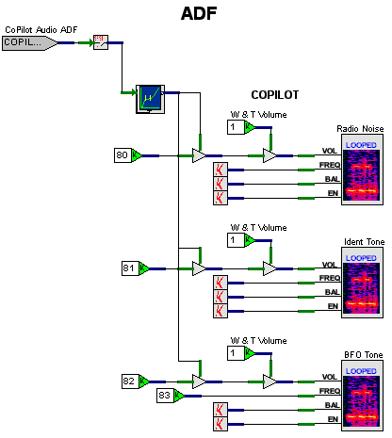
Figure 43.ADF Design (CoPilot)

7.13 Marker Beacon Design
There are two Marker Beacon radios on the Beech 1900D, so consequently we created two Marker Beacon worksheets. Since they are almost identical, we will only consider the first one here. The MarkerBeacon1design is split into two parts: the Pilot Audio, shown in , and the CoPilot Audio, Figure 45. There is only one Marker Beacon Master Volume host input which was placed at the top of the Pilot Audio figure. This input is connected to a worksheet connector so that it can be used throughout the worksheet. The other inputs that come from the host are as follows.
- Pilot Audio Mkr Bcn 1 switch
- CoPilot Audio Mkr Bcn 1 switch
- Outer Marker 1 Signal Strength
- Middle Marker 1 Signal Strength
- Inner Marker 1 Signal Strength
The Pilot Audio Mkr Bcn 1 switch combines with the Outer Marker 1 Signal Strength and the Marker Beacon Master Volume to feed the volume of the Outer Marker player object. The Outer Marker 1 Signal Strength also goes through a Float to BOOL object, which then is fed to the enable pin of the Outer Marker player. The Outer Marker player plays a 400 Hz tone, pulsing at 300 milliseconds on, and 300 milliseconds off. This pulse is produced on the output pin labeled SIG. If you needed to synchronize the Outer Marker Beacon instrument panel light with the tone pulse, you could simply hook this pin up to a host interface output port, which would send it back to the host. We didn’t do that on the Beech 1900D because our Marker Beacon lights did not need to synch up with the tone. Hence, the SIG pin is hooked up to a No Connection object.
The Middle Marker player is hooked up much the same way as the Outer Marker player, only this time we used the Middle Marker 1 Signal Strength input. A Middle Marker player plays a 1300 Hz tone, pulsing at 100 milliseconds on, 100 milliseconds off, 300 milliseconds on, 100 milliseconds off, and so on.
The Inner Marker player is hooked up to the Inner Marker 1 Signal Strength input. A Inner Marker player plays a 3000 Hz tone, pulsing at 100 milliseconds on, and 100 milliseconds off.
The CoPilot Audio part of the worksheet is set up much the same way as the Pilot Audio part. It uses the CoPilot Audio Mkr Bcn 1 switch to determine if the CoPilot can hear the marker beacon radios.

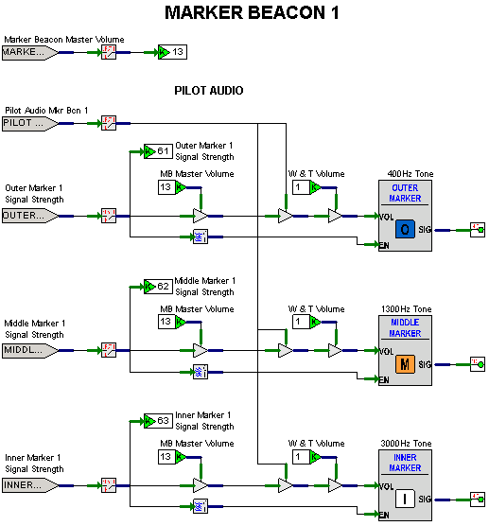
Figure 44. Marker1 Design (Pilot)

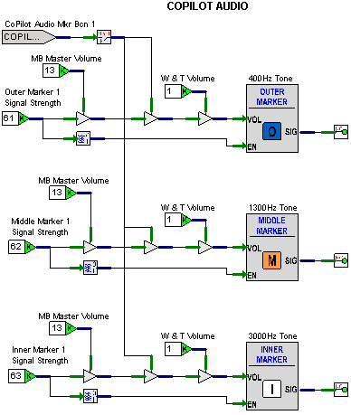
Figure 45. Marker 1 Design (CoPilot)

Cockpit Communications Using V+
The cockpit communications requirements for the Beech 1900D simulator were not that rigorous. We had two pilot stations, each with two microphones (regular headset and oxygen mask), an Instructor station, and an Observer station. We set up the voice communications for the simulator using the following as requirements.
- There are four stations: Pilot, CoPilot, Instructor, and Observer.
- The Pilot and CoPilot voice communications function as in the real aircraft.
- The Instructor and Observer always hear the Pilot and CoPilot.
- When either the Pilot or CoPilot use a PTT, the volume of their voices will increase to full in the Instructor and Observer’s headsets. Otherwise the volume of their voices will remain at half.
- If the Hot Interphone switch is on, the volume of both the Pilot and CoPilot’s voices will increase to full.
- The Instructor may transmit to the Pilot, CoPilot, both, or neither.
- The Instructor’s microphone is always transmitting to the Observer’s headset at a half-volume side-tone.
- The Instructor’s microphone is always transmitting to the Instructor’s headset at a half-volume side-tone.
- The Observer’s microphone is always transmitting to the Instructor’s headset at a half-volume side-tone.
- The Observer’s microphone is always transmitting to the Observer’s headset at a half-volume side-tone.
Controls that affect communications are shown in Table 3.
Table 3 . Communications Controls
Station | Control
Pilot | Audio control panel, COM 1 switch
Pilot | Audio control panel, COM 2 switch
Pilot | Audio control panel, speaker switch
Pilot | Audio control panel, speaker volume
Pilot | Audio control panel, headset volume
Pilot | Audio control panel, transmit selector (PA, COM 1, COM 2)
Pilot | Yoke, Comm radio Push-To-Talk (PTT) switch
Pilot | Yoke, Interphone PTT switch
Pilot | Overhead panel, Mic/Mask selector switch (Normal, Oxygen Mask)
CoPilot | Audio control panel, COM 1 switch
CoPilot | Audio control panel, COM 2 switch
CoPilot | Audio control panel, speaker switch
CoPilot | Audio control panel, speaker volume
CoPilot | Audio control panel, headset volume
CoPilot | Audio control panel, transmit selector (PA, COM 1, COM 2)
CoPilot | Yoke, Comm radio PTT switch
CoPilot | Yoke, Interphone PTT switch
CoPilot | Overhead panel, Mic/Mask selector switch (Normal, Oxygen Mask)
Pilot/CoPilot | Audio control panel, Hot interphone switch
Instructor | Transmit selector (None, Pilot, CoPilot, Both)
For the most part, the designs that follow use simple logic to combine these controls in such a way as to provide signals to the outputs, which are controls ports for the FX-30 mixer. This mixer is a Commercial-Off-The-Shelf (COTS) product manufactured by SimPhonics, and is composed of two separate cards working together. It plays an integral part in the processing of voice signals and signals coming from players in the NAV_DME, Marker, ADF, and ATIS V+ designs discussed in this article. A custom patch panel and cable had to be produced for the Beech 1900D simulator. The patch panel was manufactured by TDI, and SimPhonics manufactured the cable.
I’ve been involved in building several simulators and when it comes to voice communications for these simulators, it has always been a very difficult, one-of-a-kind problem to solve. This doesn’t have to be a nightmare! With the Audio 16 card coupled with the ISA-30 DSP, a 16 by 16 input/output matrix allows you to direct any of 16 separate inputs to any of 16 separate outputs. And it’s all made simple by… you got it – V+.
For the Beech 1900D simulator, we only needed 12 of the 16 available FX-30 inputs, and 6 of the available 16 FX-30 outputs for taking care of the voice communications requirements. The FX-30 allocated channels for the inputs are shown in Table 4. Note that players dealing with nav audio are treated as inputs to the FX-30 (they come out of the player and into the FX-30). The output of the ATIS system is also an input to the FX-30.
Table 4. FX-30 Inputs
Channel | Description
1 | Pilot Headset Microphone
2 | Pilot Oxygen Microphone
3 | Pilot Handheld Microphone
4 | CoPilot Headset Microphone
5 | CoPilot Oxygen Microphone
6 | CoPilot Handheld Microphone
7 | Instructor Headset Microphone
8 | Observer Headset Microphone
9 | Pilot Nav Audio
10 | CoPilot Nav Audio
11 | Installed spare
12 | ATIS Audio Output, left channel
13 | ATIS Audio Output, right channel
14 - 16 | Installed Spares
Table 5. FX-30 Outputs
Channel | Description
1 | Pilot Headset
2 | CoPilot Headset
3 | Instructor Headset
4 | Observer Headset
5 | Pilot Overhead Output to Speaker Amplifier
6 | CoPilot Overhead Output to Speaker Amplifier
7 - 16 | Installed Spares
The FX-30 allocated channels for the outputs are shown in Table 5. Each FX-30 output has 16 inputs and one master gain associated with it. These 17 items per FX-30 output are treated as output ports in a list shown in Figure 46 (you need to select the DSP 1 Output I/O Device at the top of the Ports window to see the list shown in the figure).
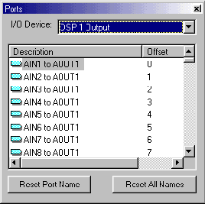
Figure 46. DSP Output Ports
The following four sections discuss the V+ designs associated with voice communications. Although ATIS is really a synthetic voice, I chose to talk about it here because it uses inputs from the Comm radio heads.

8.1 IOSCommLogic Design
The IOSCommLogic worksheet is split into two parts and shown in Figure 47 and Figure 48. The first part is the logic for the Instructor. The second part is the logic for the Observer. At the top of the first part is a DSP output port labeled IOS Headset Master. A constant 1.0 is wired to it that enables the IOS headset at all times.
There is one input coming from the host called Instructor Transmit Selector. This is wired to two One of Eight Selector objects. Each of these selectors only deals with input values of 1, 2, or 3 (Pilot, CoPilot, or Both). The other five selector pins are shunted to No Connection objects. Now let’s look at the logic for the first selector. We used two Logical OR objects to perform the following logic.
if (instructor_tramsit_selector == PILOT) OR (instructor_tramsit_selector == BOTH)
{
set IOS Mic to Pilot Headset = 1.0
set transmitting = TRUE
}
else
{
set IOS Mic to Pilot Headset = 0.0
set transmitting = FALSe
}

if (instructor_tramsit_selector == COPILOT) OR (instructor_tramsit_selector == BOTH)
{
set IOS Mic to CoPilot Headset = 1.0
set transmitting = TRUE
}
else
{
set IOS Mic to CoPilot Headset = 0.0
set transmitting = FALSE
}

The outputs of these Logical ORs are then wired to another OR , which then feeds a 1 of 2 Selector object. There are two constants wired to this object. The first, labeled LOW has a value of 0.5, and the second, labeled HIGH has a value of 1.0. If the control pin is FALSE, the LOW value is passed to the output IOS Mic Sidetone. If the control pin is TRUE, the HIGH value is passed to IOS Mic Sidetone. Another way to look at it is as follows.
if (transmitting == TRUE)
set IOS Mic to IOS Headset = 1.0
else
set IOS Mic to IOS Headset = 0.5

The second One of Eight Selector is used to transmit the Instructor’s mic signal to the Pilot and CoPilot’s overhead speakers. Two more inputs are added to the logic. They are the Pilot Audio Speaker and CoPilot Audio Speaker worksheet connectors from the PilotCommLogic and CoPilotCommLogic designs. These inputs and the results of the Logicals ORs are ANDed together to feed the Instructor’s mic signal to the appropriate overhead speaker. Here’s the textual logic.
if (pilot_audio_speaker_switch == ON) AND
((instructor_tramsit_selector == PILOT) OR (instructor_tramsit_selector == BOTH))
set IOS Mic to Pilot Overhead = 1.0
else
set IOS Mic to Pilot Overhead = 0.0

if (copilot_audio_speaker_switch == ON) AND
((instructor_tramsit_selector == COPILOT) OR (instructor_tramsit_selector == BOTH))
set IOS Mic to CoPilot Overhead = 1.0
else
set IOS Mic to CoPilot Overhead = 0.0

At the bottom of Figure 47 are small models to allow the Instructor to always hear both pilots. They use the worksheet connectors Pilot Mic Hot and CoPilot Mic Hot from the PilotCommLogic and CoPilotCommLogic designs. These are fed into a 1 of 2 Selector. If a mic is hot, meaning a pilot is transmitting, then the signal strength of that mic is fed to the instructor headset with a value of 1.0 Otherwise, the value is 0.5, like sidetone.

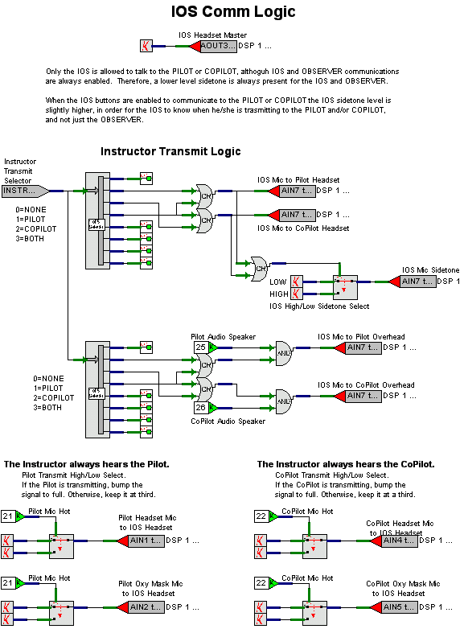
Figure 47. IOSCommLogic Design (Instructor)
The Observer part of the IOSCommLogic design is pretty simple. First, we enable the headset and set a constant sidetone from the Observer’s mic to the Observer’s headset. Then we feed the Observer’s mic to the Instructor’s headset, and the Instructor’s mic to the Observer’s headset at a constant signal value of 0.5. At the bottom of the Observer’s design is logic similar to that found at the bottom of the Instructor’s design. The Observer will also hear the pilots at a higher volume when they are transmitting, and hear them at a sidetone level when they are not.

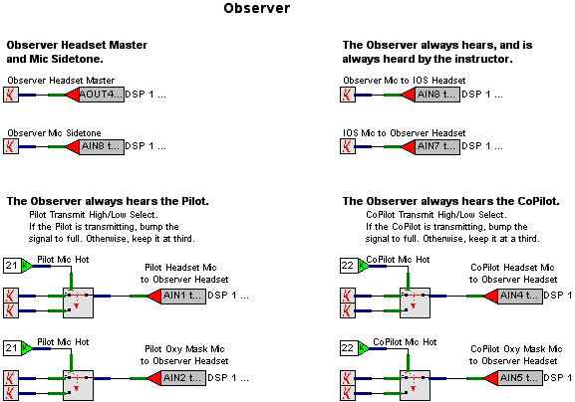
Figure 48. IOSCommLogic Design (Observer)

8.2 PilotCommLogic Design
The PilotCommLogic worksheet is shown in Figure 49. Now that you’ve had a little taste of logic, let’s get a little more into it.
At the top of the worksheet are two host inputs: Pilot Audio COM 1 and Pilot Audio COM 2. These are wired directly to worksheet connectors for use elsewhere. Even though they aren’t used in this worksheet, we put them here since they are associated with Pilot communications.
Next we see a comment block that textually explains the logic below it. Since this comment block pretty well explains what’s going on, I won’t try to confuse the issue by expounding upon it. However, I do want to point out a couple of things. There are a couple of worksheet connectors that are created for Hot Interphone and for Pilot Mic Hot. Since there’s only one Hot Interphone switch, we put it here and fed it to a connector for use later by the CoPilotCommLogic design. The Pilot Mic Hot connector is used by the Instructor and Observer comm designs.
Down below we have two more models: Pilot Headset Control and Pilot Overhead Speaker Control. The first one wires the host input Pilot Headset Volume directly to the DSP outputs Pilot Headset Master and Pilot Nav Audio to Pilot Headset. The host inputs Pilot Speaker Volume and Pilot Audio Speaker switch combine to feed the DSP outputs Pilot Overhead Master and Pilot Nav Audio to Pilot Overhead. The Pilot Audio Speaker input is also directly wirred to a worksheet connector for use here and in the Instructor designs.

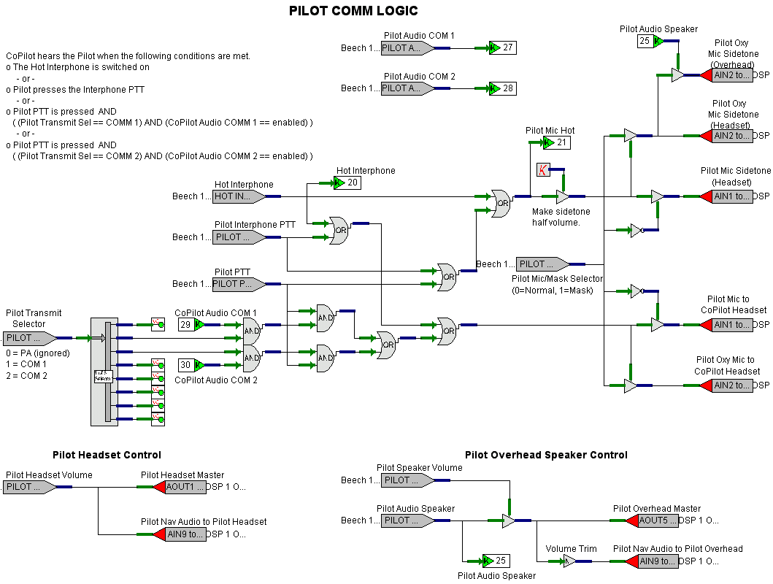
Figure 49. PilotCommLogic Design

8.3 CoPilotCommLogic Design
Figure 50 is the worksheet for the CoPilotCommLogic design. This is similar to the PilotCommLogic differing only in the inputs and outputs.

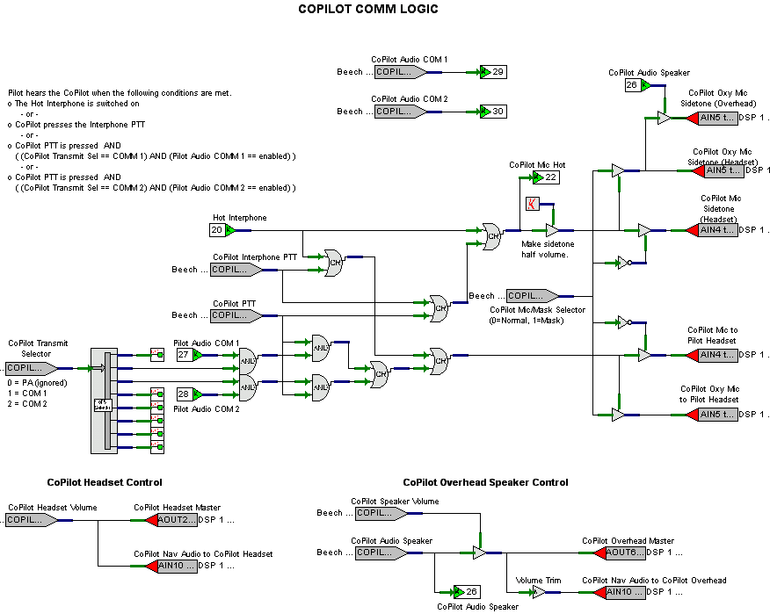
Figure 50. CoPilotCommLogic Design

8.4 ATIS Design
Automatic Terminal Information Service (ATIS) broadcasts airport weather information on VHF communications frequencies throughout the USA. The FAA uses a Speech to Text engine to automatically convert text to speech for the following information.
- Airport identification
- ATIS information sequence code
- Time of last update
- Ceiling
- Visibility
- Temperature
- Dewpoint
- Wind direction and speed
- Barometric pressure
SimPhonics simulates ATIS using the V+ Text to Speech I/O Device. This device incorporates V+ with the Microsoft® Text-to-Speech engine, to “broadcast” airport weather information through the simulator’s cockpit communications. There are two files that support this effort: the ATIS V+ worksheet design, shown in Figure 53 and Figure 55, and the ATIS.txt file shown in Figure 54. Let’s discuss the first part of the ATIS V+ worksheet first.
For the most part, the ATIS worksheet takes inputs from the host and passes them to the Text to Speech I/O Device. It does this by hooking up to the appropriate speech synthesizer output ports. To view the list of available ports for the speech synthesizer, you bring up the Ports window by clicking on the ports icon while in the V+ development system. Select the Speech Synthesizer Output Data I/O Device at the top of the Ports window and you’ll see a list as shown in Figure 51. The ports are sequentially numbered starting at 0 and going to the maximum specified in the Number of Speech Tag Ports box during Speech Synthesizer Configuration (refer to the V+ Text To Speech I/O Device User Manual for more details). On the Beech 1900D we used ports 1 through 12, ignoring 0 and 13 through 50. The following inputs were provided from the host.
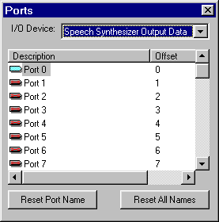
Figure 51. Speech Synthesizer Output Data Ports
How are these ports mapped to the host inputs? Table 6 provides this mapping along with a description of each element. This is also described at the top of the ATIS.txt file. You may have noticed that the input Altimeter Setting is split into two parts: integer and decimal. This is done due to an idiosyncrasy of the speech engine – it ignores the decimal part of a number. We want an altimeter setting of say 29.92 to be spoken as “two nine point nine two.” To do this we send the input through a Separate into Integer and Fraction object, whose integer portion goes directly to output port 11. The fractional part is then multiplied by 100 and fed to output port 12.
Table 6. Host Inputs to Speech Synthesizer Outputs
Host Input | Description | Speech Synth Output Port
Airport ID | Unique Airport Identification code, as defined in ATIS.txt. | 1
ATIS Info Code | Information sequence code, ASCII characters 65 to 90 (A to Z). | 2
Ceiling Type | Airport ceiling type, as defined in ATIS.txt. | 3
Ceiling | Airport cloud ceiling in feet. | 4
Visibility | Airport visibility in miles. | 5
Visibility Modifier | Visibility modifier, as defined in ATIS.txt. | 6
Temperature | Airport temperature in degrees Celsius. | 7
Dewpoint | Airport dewpoint in degrees Celsius. | 8
Wind Speed | Airport wind speed in knots. | 9
Wind Direction | Airport wind direction in degrees. | 10
Altimeter Setting (integer part) | Airport barometric pressure in inches of mercury (integer part). | 11
Altimeter Setting (decimal part) | Airport barometric pressure in inches of mercury (decimal part). | 12

At the bottom of the worksheet there’s a section called Speech Synthesizer Control. This allows us to enable the speech engine, and to have the it continually repeat the text. There are two input ports called Com1 ATIS Enable and Com2 ATIS Enable that come from the host. The host determines if either of the VHF communications radios has tuned to the correct ATIS frequency for the currently selected airport. If true, it sets the appropriate enable flag. These inputs are wired to a Logical OR object whose output goes to the Enable port. Just above this logic, is a constant wired to a port labeled Repeat. With the constant set to 1.0, this tells the speech engine to continually repeat the text found in ATIS.txt. These two ports, can be found in the Ports window by selecting the Speech Synthesizer Control I/O device, shown in Figure 52.
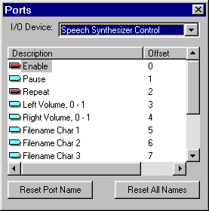
Figure 52. Speech Synthesizer Control Ports
Now let’s talk a little bit about the ATIS.txt file. This file is what the speech engine reads and “vocalizes.” It’s pretty straight forward, but there are some twists. The speech engine will say everything that is in the text file except for comments and logic that is encapsulated within curly braces ({}). Comments start with two slashes (//) at the beginning of a line. Logic is used to decode what’s in a port location. For instance, the first 17 logic statements check port 1 (Airport ID) for the value corresponding to the textual name for that airport. If value in port 1 is equal to say 5, the speech engine would say “Kennedy Airport.” Sometimes the speech engine doesn’t get the intonation of a word quite right. Hence you’ll see different spellings for Cincinnati, Milwakee, fog, and winds.
At the bottom of ATIS.txt, is a command that tells the device to wait 4 seconds before repeating. For more information on this command, and many more like it, refer to the V+ Text to Speech Device, refer to the V+ Text To Speech I/O Device User Manual.
The second part of the ATIS V+ worksheet (Figure 55), deals with the volume level of the ATIS. There are two models on this worksheet: one that handles ATIS volume in the Pilot’s headset and overhead speaker, and one that handles the ATIS volume in the CoPilot’s headset and overhead speaker. These models are very similar, so we’ll only consider the pilot’s model.
There are four inputs and two outputs in this model. Two of the inputs are the COM 1 Master Volumes and COM 2 Master Volume. These are the volume control knobs on the radio heads. The other two inputs are worksheet connectors that come from PilotCommLogic. They are the Pilot COM 1 and COM 2 switches located on the audio control panel. These switches are either on or off, with values of 1 or 0 respectively. In the top half of the model, the COM 1 volume is multiplied by the COM 1 switch resulting in either 0 or the setting of the volume knob. In the bottom half, the COM 2 volume is multiplied by the COM 2 switch to produce a similar result. These two results are then added together, limited to 1, and fed to the two DSP outputs: ATIS to Pilot Headset and ATIS to Pilot Overhead Speaker. Adding the two comm radio signals together and then limiting the result to 1 is not totally real-world accurate, but close enough for simulator purposes. The reason for the limiting is because the DSP will react strangely to a value greater than 1.
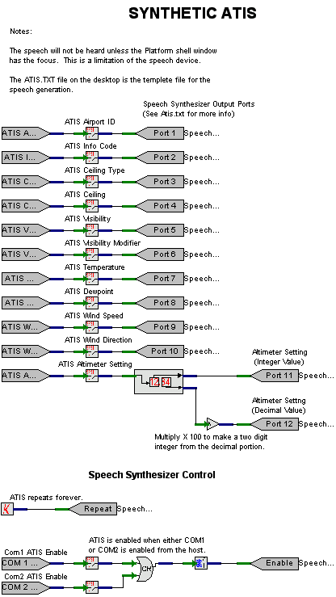
Figure 53. ATIS Design

Figure 54. ATIS.txt File
//***************************************************************
//
// ATIS TEXT TEMPLATE
//
// VERSION: 1.0 - June 17th, 1999
// AUTHOR: Stephen Jones
//
//***************************************************************
//
// DESCRIPTION
//
// This text file is used by the V+ text to speech I/O device to
// produce a simulated ATIS (Automatic Terminal Information Service)
// broadcast.
//
// Port Assignments:
//
// Port 1: Airport ID
// Port 2: ATIS Ident Code
// Port 3: Ceiling Type:
// 1 = Unlimited
// 2 = broken
// 3 = Overcast
//
// Port 4: Ceiling in feet
// Port 5: Visibility in miles
// Port 6: Visibility Modifier Type
// 1 = Fog
// 2 = Rain
//
// Port 7: Temperature in degrees
// Port 8: Dew Point
// Port 9: Wind Speed
// Port 10: Wind Direction
// Port 11: Altimeter Setting (Integer Value)
// Port 12: Altimeter Setting (Decimal Value)
//
//***************************************************************

This is
{if port 1 = 1}Denver International Airport,,{end if}
{if port 1 = 2}O'Hare International Airport,,{end if}
{if port 1 = 3}Albuquerque International Airport,,{end if}
{if port 1 = 4}Boston Logan Airport,,{end if}
{if port 1 = 5}Kennedy Airport,,{end if}
{if port 1 = 6}Newark Airport,,{end if}
{if port 1 = 7}Philadelphia International Airport,,{end if}
{if port 1 = 8}Washington Dulles International Airport,,{end if}
{if port 1 = 9}Atlanta International Airport,,{end if}
{if port 1 = 10}Sinsin ati International Airport,,{end if} // "Sinsin ati" = Cinncinnati
{if port 1 = 11}Dallas Fort Worth International Airport,,{end if}
{if port 1 = 12}Detroit Metropolitan Airport,,{end if}
{if port 1 = 13}Houston Intercontinental Airport,,{end if}
{if port 1 = 14}Miami International Airport,,{end if}
{if port 1 = 15}Mil wawkee International Airport,,{end if} // "Mil wawkee" = Milwakee
{if port 1 = 16}Montreal International Airport,,{end if}
{if port 1 = 17}Pittsburgh International Airport,,{end if}

// Convert the ATIS Ident code into the phonetic alphabet
//
Information,
{if port 2 = 0}Whiskey{end if}
{if port 2 = 65}Alpha{end if}
{if port 2 = 66}Bravo{end if}
{if port 2 = 67}Charlie{end if}
{if port 2 = 68}Delta{end if}
{if port 2 = 69}Echo{end if}
{if port 2 = 70}Foxtrot{end if}
{if port 2 = 71}Golf{end if}
{if port 2 = 72}Hotel{end if}
{if port 2 = 73}India{end if}
{if port 2 = 74}Juliett{end if}
{if port 2 = 75}Kilo{end if}
{if port 2 = 76}Lima{end if}
{if port 2 = 77}Mike{end if}
{if port 2 = 78}November{end if}
{if port 2 = 79}Oscar{end if}
{if port 2 = 80}Papa{end if}
{if port 2 = 81}Quebec{end if}
{if port 2 = 82}Romeo{end if}
{if port 2 = 83}Sierra{end if}
{if port 2 = 84}Tango{end if}
{if port 2 = 85}Uniform{end if}
{if port 2 = 86}Victor{end if}
{if port 2 = 87}Whiskey{end if}
{if port 2 = 88}Xray{end if}
{if port 2 = 89}Yankee{end if}
{if port 2 = 90}Zoo-loo{end if}
.

{time}, zoo-loo.

Ceiling,
// Ceiling types
{if port 3 = 1}unlimited.{end if}
{if port 3 = 2} {say port informal integer 4} broken.{end if}
{if port 3 = 3} {say port informal integer 4} overcast.{end if}

Visibility, {say port integer 5} miles,

// Visibility modifier types
{if port 6 = 1} and fawg.{end if}
{if port 6 = 2} and rain.{end if}
Temperature,
{say port integer 7}.

Dew point,
{say port integer 8}.

// Winds
Weends,
{if port 9 < 3} calm.{end if}
{if port 9 > 2} {say port integer 10} at {say port integer 9}.{end if}

// Altimeter
Altimeter,
{say port integer 11} point {say port integer 12}.

Figure 54. ATIS.txt File (continued)

Figure 54. ATIS.txt File (concluded)
Advise on initial contact you have information,
{if port 2 = 0}Whiskey{end if}
{if port 2 = 65}Alpha{end if}
{if port 2 = 66}Bravo{end if}
{if port 2 = 67}Charlie{end if}
{if port 2 = 68}Delta{end if}
{if port 2 = 69}Echo{end if}
{if port 2 = 70}Foxtrot{end if}
{if port 2 = 71}Golf{end if}
{if port 2 = 72}Hotel{end if}
{if port 2 = 73}India{end if}
{if port 2 = 74}Juliett{end if}
{if port 2 = 75}Kilo{end if}
{if port 2 = 76}Lima{end if}
{if port 2 = 77}Mike{end if}
{if port 2 = 78}November{end if}
{if port 2 = 79}Oscar{end if}
{if port 2 = 80}Papa{end if}
{if port 2 = 81}Quebec{end if}
{if port 2 = 82}Romeo{end if}
{if port 2 = 83}Sierra{end if}
{if port 2 = 84}Tango{end if}
{if port 2 = 85}Uniform{end if}
{if port 2 = 86}Victor{end if}
{if port 2 = 87}Whiskey{end if}
{if port 2 = 88}Xray{end if}
{if port 2 = 89}Yankee{end if}
{if port 2 = 90}Zoo-loo{end if}.

// Pause for 4 seconds.
//
\pau=4000\

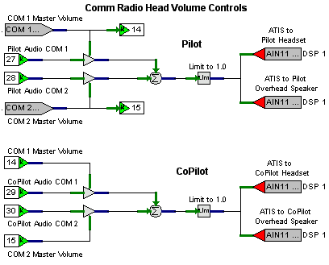
Figure 55. ATIS Design (Comm Radio Head Volume Controls)

Afterword
It’s probably pretty apparent to you that I’m sold on the SimPhonics solution for simulating sound and voice communication. I’ve worked on quite a few simulators and sound systems for those simulators have never been an easy proposition. SimPhonics made it easy once I understood how their system worked. With V+, you can easily tune the system during real time, change a design on the fly, and add new elements to the host interface. It made life easier for me during FAA qualification crunch time, which is probably the most stressful time during a simulator build. And now, SimPhonics is introducing a new product that will make things even easier.
Welcome the SMx system! The SMx is a replacement system for the FX-30 system. It provides 50 channels in and 50 channels out per controller card, and does it at better than CD quality of 44.1kHz, 24 bit. It’s coupled with a 32 bit WDM streaming driver for better DirectX performance. In other words, while designed for simulation and training with HLA and DIS compliance, the system can also be used as a complete digital audio studio with a mixer console and a hard disk recorder built in. No longer will sound cards be needed to play WAVE files in a SimPhonics system. This reduces the card count in the SimPhonics computer, and makes the cabling for voice communications much easier.
SimPhonics is continually committed to providing state-of-the-art simulation products. They continue to expand their V+ object list, and are being used in things other than just sound systems (such as I/O systems). I can easily envision V+ being used for modeling aircraft systems such as electrical, navigation, hydraulics, pneumatics, etc. In short, I think it could make simulation modeling fast and easy, cutting down time to market significantly.

This appendix provides specifications for the speakers and amplifiers for TDI’s Beech 1900D Level C simulator. Table A-1 contains the amplifier/speaker allocation. All four amplifiers are identical.

Table A-1. Amplifier/Speaker Allocation
Amplifier | Channel | Speaker
1 | Left | Left Front
1 | Right | Right Front
2 | Left | Left Overhead
2 | Right | Right Overhead
3 | Left | Left Rear
3 | Right | Right Rear
4 | Left | Sub-Woofer
4 | Right | unused

Front Speakers

Sony XS-V1655G
http://www.xplodsony.com/products/?CATEGORY=Speakers&MD=XS-V1655G

Peak Input Power: 200 W
Rated Input Power: 50 W
Nominal Impedance: 4 ohms
Sensitivity: 90dB/W/m
Frequency Response: 30 to 26,000 Hz

Overhead and Rear Speakers

Infinity KAPPA 693.1I

http://www.infinitysystems.com/caraudio/product.asp?ProdId='KAPPA+693%2E1I'&Ser=KAP&Cat=MEL

Peak Input Power: 300 W
Rated Input Power: 100 W
Nominal Impedance: 4 ohms
Sensitivity: 89dB
Frequency Response: (±1.5 dB) 38 to 21,000 Hz

Subwoofer Speaker

Infinity KAPPA 120.1SE
http://www.infinitysystems.com/caraudio/product.asp?ProdId='KAPPA120%2E1SE'&Ser=KAP&Cat=SUB

Rated Input Power: 300 W
Nominal Impedance: 4 ohms
Sensitivity: 94dB 2.83V/1m
Frequency Response: 25 to 250 Hz

Subwoofer Enclosure

Crutchfield Q-Logic QB-11221SE
http://www.crutchfield.com/cgi-bin/S-oLd3wBsIRIp/ProdView.asp?s=0&c=3&g=842&I=044QB1122&o=M&a=0

Dimensions:
Width: 16 1/8”
Height: 16 1/2”
Depth: 16 1/8”

Amplifiers

Carvin HT760M
http://www.carvin.com/cgi-bin/get.exe?PAGE=adetail&CFG=2&SearchStr=(I.ItemNumber='HT760M')+AND+(CID2='PWA')

Bridged Continuous Power:
4Ω: 700W
8Ω: 480W

Both Channels Continuous Power:
2Ω: 350W/350W
4Ω: 250W/250W
8Ω: 175W/175W

Frequency Response: (±0.5 dB) 20 to 20,000 Hz
Total Harmonic Distortion: 0.03% at half power
Damping Factor: >350
Slew Rate: >45v/μs (bridged mode)
Sensitivity: 1.0v (4Ω, Vms)
Signal-to-Noise Ratio: >100dB
Input Impedance: >20KΩ, balanced

The following table contains data from the HostBuffer table for the Beech 1900D simulator.

HostRef | HostName | DataType | Notes
0 | MUTE ENVIRONMENTAL SOUND | dword | 0=Not Mute, 1=Mute
1 | MUTE WARNINGS AND TONES | dword | 0=Not Mute, 1=Mute
2 | HOST COUNTER | dword | Incremented (In freeze & run) at 30Hz
3 | INSTRUCTOR’S SOUND LEVEL CONTROL | float | Limits 0.0 to 1.0, 0.75 Normal Setting, affects only environmental sound.
4 | ENGINE 1 IGNITER ON | dword | 0=Off, 1=On
5 | ENGINE 1 COMPRESSOR STALL | dword | 0=Off, 1=On
6 | ENGINE 1 COMBUSTION ON | dword | 0=Off, 1=On
7 | ENGINE 1 STARTER ENGAGED | dword | 0=Off, 1=On
8 | ENGINE 1 PROP TORQUE | float | ft/lbs. Range, 0.0 to 5000.0
9 | ENGINE 1 TURBINE RPM | float | Limits 0.0 to 1.0 1.0 = Max
10 | ENGINE 1 PROP RPM | float | Limits 0.0 to 1.0 1.0 = Max
11 | ENGINE 1 PROP BLADE ANGLE | float | Limits 0.0 = 0 Degrees Pitch, 1.0 = Fully Feathered
12 | ENGINE 2 IGNITER ON | dword | 0=Off, 1=On
13 | ENGINE 2 COMPRESSOR STALL | dword | 0=Off, 1=On
14 | ENGINE 2 COMBUSTION ON | dword | 0=Off, 1=On
15 | ENGINE 2 STARTER ENGAGED | dword | 0=Off, 1=On
16 | ENGINE 2 PROP TORQUE | float | ft/lbs. Range, 0.0 to 5000.0
17 | ENGINE 2 TURBINE RPM | float | Limits 0.0 to 1.0 1.0 = Max
18 | ENGINE 2 PROP RPM | float | Limits 0.0 to 1.0 1.0 = Max
19 | ENGINE 2 PROP BLADE ANGLE | float | Limits 0.0 = 0 Degrees Pitch, 1.0 = Fully Feathered
20 | BOOST PUMP 1 ON | dword | 0=Off, 1=On
21 | BOOST PUMP 2 ON | dword | 0=Off, 1=On
22 | FLAP POSITION | float | Limits 0.0 to 1.0, 1.0 = Fully Extended
23 | GYRO POWER HORN ON | dword | 0=Off, 1=On
24 | WINDSHIELD DEFROST ON | dword | 0=Off, 1=On
25 | RUNWAY SURFACE TYPE | dword | 0 - Invalid, 1 - Hard Smooth Surface, 2 - Hard Rough Surface, 3 - Soft Smooth Surface, 4 - Soft Rough Surface
26 | LEFT MAIN GEAR POSITION | float | Limits 0.0 to 1.0, 1.0 = Fully Extended
27 | RIGHT MAIN GEAR POSITION | float | Limits 0.0 to 1.0, 1.0 = Fully Extended
28 | NOSE GEAR POSITION | float | Limits 0.0 to 1.0, 1.0 = Fully Extended
29 | LEFT MAIN GEAR DOOR POSITION | float | Limits 0.0 to 1.0, 1.0 = Fully Open
30 | RIGHT MAIN GEAR DOOR POSITION | float | Limits 0.0 to 1.0, 1.0 = Fully Open
31 | NOSE GEAR DOOR POSITION | float | Limits 0.0 to 1.0, 1.0 = Fully Open
32 | LEFT MAIN GEAR LOAD | float | Limits 0.0 to 1.0 1.0 = Max
33 | RIGHT MAIN GEAR LOAD | float | Limits 0.0 to 1.0 1.0 = Max
34 | NOSE GEAR LOAD | float | Limits 0.0 to 1.0 1.0 = Max
35 | LEFT MAIN TIRE BLOW | dword | 0=Off, 1=On
36 | RIGHT MAIN TIRE BLOW | dword | 0=Off, 1=On
37 | NOSE TIRE BLOW | dword | 0=Off, 1=On
38 | EXPLOSIVE DECOMPRESSION | dword | 0=Off, 1=On
39 | DIFFERENTIAL PRESSURE | float | 0.0 to 1.0 Ratio. 1.0 = No differential
40 | MID AIR CRASH | dword | 0=Off, 1=On
41 | CRASH TYPE 1 | dword | 0=Off, 1=On
42 | CRASH TYPE 2 | dword | 0=Off, 1=On
43 | LEFT WINDSHIELD WIPERS SPEED | float | 0=off, 0.5=Slow, 1.0=Fast, Park = 0.5 for .75 seconds then off.
44 | RIGHT WINDSHIELD WIPERS SPEED | float | 0=off, 0.5=Slow, 1.0=Fast, Park = 0.5 for .75 seconds then off.
45 | THUNDER | dword | 0=Off, 1=On
46 | HAIL | dword | 0=Off, 1=On
47 | RAIN INTENSITY | float | Limits 0.0 to 1.0 1.0 = Max
48 | AIR IMPACT PRESSURE | float | 0.0 to 1.0, 1.0 = Vne in true airspeed.
49 | GROUND SPEED | float | 0.0-130.0 knots
50 | OUTER MARKER 1 SIGNAL STRENGTH | float | Limits 0.0 to 1.0 1.0 = Max
51 | MIDDLE MARKER 1 SIGNAL STRENGTH | float | Limits 0.0 to 1.0 1.0 = Max
52 | INNER MARKER 1 SIGNAL STRENGTH | float | Limits 0.0 to 1.0 1.0 = Max
53 | MARKER BEACON MASTER VOLUME | float | Limits 0.0 to 1.0 1.0 = Max
54 | ALTITUDE ALERT WARNING | dword | 0=Off, 1=On
55 | PILOT DECISION HEIGHT WARNING | dword | 0=Off, 1=On
56 | COPILOT DECISION HEIGHT WARNING | dword | 0=Off, 1=On
57 | OVERSPEED WARNING | dword | 0=Off, 1=On
58 | STALL WARNING | dword | 0=Off, 1=On
59 | LANDING GEAR WARNING | dword | 0=Off, 1=On
60 | GPWS PULL UP URGENT | dword | 0=Off, 1=On
61 | GPWS SINK RATE | dword | 0=Off, 1=On
62 | GPWS PULL UP | dword | 0=Off, 1=On
63 | GPWS TERRAIN PULLUP | dword | 0=Off, 1=On
64 | GPWS TERRAIN | dword | 0=Off, 1=On
65 | GPWS DON’T SINK | dword | 0=Off, 1=On
66 | GPWS TOO LOW FLAPS | dword | 0=Off, 1=On
67 | GPWS TOO LOW GEAR | dword | 0=Off, 1=On
68 | GPWS TOO LOW TERRAIN | dword | 0=Off, 1=On
69 | GPWS GLIDESLOPE 1 URGENT | dword | 0=Off, 1=On
70 | GPWS GLIDESLOPE 1 | dword | 0=Off, 1=On
71 | GPWS GLIDESLOPE 2 | dword | 0=Off, 1=On
72 | GPWS GLIDESLOPE 3 | dword | 0=Off, 1=On
73 | GPWS 500 ALTITUDE CALLOUT | dword | 0=Off, 1=On
74 | GPWS 200 ALTITUDE CALLOUT | dword | 0=Off, 1=On
75 | GPWS MINIMUMS | dword | 0=Off, 1=On
76 | GPWS BANK ANGLE | dword | 0=Off, 1=On
77 | GPWS NORMAL SELF TEST | dword | 0=Off, 1=On
78 | GPWS GLIDESLOPE FAULT | dword | 0=Off, 1=On
79 | GPWS BARO RATE FAULT | dword | 0=Off, 1=On
80 | GPWS RADIO ALTITUDE FAULT | dword | 0=Off, 1=On
81 | TCAS FAILED VOICE WARNING | dword | 0=Off, 1=On
82 | TCAS PASSED VOICE WARNING | dword | 0=Off, 1=On
83 | TCAS TEST VOICE WARNING | dword | 0=Off, 1=On
84 | TCAS TRAFFIC | dword | 0=Off, 1=On
85 | COM 1 MASTER VOLUME | float | Limits 0.0 to 1.0 1.0 = Max
86 | COM 2 MASTER VOLUME | float | Limits 0.0 to 1.0 1.0 = Max
87 | COM 1 SIGNAL TO NOISE RATIO | float | Limits 0.0 to 1.0 1.0 = Max
88 | COM 2 SIGNAL TO NOISE RATIO | float | Limits 0.0 to 1.0 1.0 = Max
89 | NAV 1 RECEIVER MASTER VOLUME | float | Limits 0.0 to 1.0 1.0 = Max
90 | NAV 1 SIGNAL TO NOISE RATIO | float | Limits 0.0 to 1.0 1.0 = Max
91 | NAV 1 IDENT LETTERS 1 | char | ASCII Value of Character
92 | NAV 1 IDENT LETTERS 2 | char | ASCII Value of Character
93 | NAV 1 IDENT LETTERS 3 | char | ASCII Value of Character
94 | NAV 1 IDENT LETTERS 4 | char | ASCII Value of Character
95 | DME 1 RECEIVER MASTER VOLUME | float | Limits 0.0 to 1.0 1.0 = Max
96 | DME 1 SIGNAL TO NOISE RATIO | float | Limits 0.0 to 1.0 1.0 = Max
97 | NAV 1 DME IDENT LETTERS 1 | char | ASCII Value of Character
98 | NAV 1 DME IDENT LETTERS 2 | char | ASCII Value of Character
99 | NAV 1 DME IDENT LETTERS 3 | char | ASCII Value of Character
100 | NAV 1 DME IDENT LETTERS 4 | char | ASCII Value of Character
101 | NAV 2 RECEIVER MASTER VOLUME | float | Limits 0.0 to 1.0 1.0 = Max
102 | NAV 2 SIGNAL TO NOISE RATIO | float | Limits 0.0 to 1.0 1.0 = Max
103 | NAV 2 IDENT LETTERS 1 | char | ASCII Value of Character
104 | NAV 2 IDENT LETTERS 2 | char | ASCII Value of Character
105 | NAV 2 IDENT LETTERS 3 | char | ASCII Value of Character
106 | NAV 2 IDENT LETTERS 4 | char | ASCII Value of Character
107 | DME 2 RECEIVER MASTER VOLUME | float | Limits 0.0 to 1.0 1.0 = Max
108 | DME 2 SIGNAL TO NOISE RATIO | float | Limits 0.0 to 1.0 1.0 = Max
109 | NAV 2 DME IDENT LETTERS 1 | char | ASCII Value of Character
110 | NAV 2 DME IDENT LETTERS 2 | char | ASCII Value of Character
111 | NAV 2 DME IDENT LETTERS 3 | char | ASCII Value of Character
112 | NAV 2 DME IDENT LETTERS 4 | char | ASCII Value of Character
113 | ADF 1 RECEIVER MASTER VOLUME | float | Limits 0.0 to 1.0 1.0 = Max
114 | ADF 1 SIGNAL TO NOISE RATIO | float | Limits 0.0 to 1.0 1.0 = Max
115 | ADF 1 IDENT LETTERS 1 | char | ASCII Value of Character
116 | ADF 1 IDENT LETTERS 2 | char | ASCII Value of Character
117 | ADF 1 IDENT LETTERS 3 | char | ASCII Value of Character
118 | ADF 1 IDENT LETTERS 4 | char | ASCII Value of Character
119 | ADF 1 FREQ DIFF | float | +/-7000 Hz
120 | ADF BFO ON | dword | 0=Off, 1=On
121 | PILOT AUDIO COM 1 | dword | 0=Off, 1=On
122 | PILOT AUDIO COM 2 | dword | 0=Off, 1=On
123 | PILOT AUDIO NAV 1 | dword | 0=Off, 1=On
124 | PILOT AUDIO NAV 2 | dword | 0=Off, 1=On
125 | PILOT AUDIO MKR BCN 1 | dword | 0=Off, 1=On
126 | PILOT AUDIO MKR BCN 2 | dword | 0=Off, 1=On
127 | PILOT AUDIO DME 1 | dword | 0=Off, 1=On
128 | PILOT AUDIO DME 2 | dword | 0=Off, 1=On
129 | PILOT AUDIO ADF | dword | 0=Off, 1=On
130 | PILOT AUDIO SPEAKER | dword | 0=Off, 1=On
131 | PILOT TRANSMIT SELECTOR | dword | 0 = PA, 1 = COM 1, 2 = COM 2
132 | COPILOT AUDIO COM 1 | dword | 0=Off, 1=On
133 | COPILOT AUDIO COM 2 | dword | 0=Off, 1=On
134 | COPILOT AUDIO NAV 1 | dword | 0=Off, 1=On
135 | COPILOT AUDIO NAV 2 | dword | 0=Off, 1=On
136 | COPILOT AUDIO MKR BCN 1 | dword | 0=Off, 1=On
137 | COPILOT AUDIO MKR BCN 2 | dword | 0=Off, 1=On
138 | COPILOT AUDIO DME 1 | dword | 0=Off, 1=On
139 | COPILOT AUDIO DME 2 | dword | 0=Off, 1=On
140 | COPILOT AUDIO ADF | dword | 0=Off, 1=On
141 | COPILOT AUDIO SPEAKER | dword | 0=Off, 1=On
142 | COPILOT TRANSMIT SELECTOR | dword | 0 = PA, 1 = COM 1, 2 = COM 2
143 | PILOT SPEAKER VOLUME | float | Limits 0.0 to 1.0 1.0 = Max
144 | PILOT HEADSET VOLUME | float | Limits 0.0 to 1.0 1.0 = Max
145 | COPILOT SPEAKER VOLUME | float | Limits 0.0 to 1.0 1.0 = Max
146 | COPILOT HEADSET VOLUME | float | Limits 0.0 to 1.0 1.0 = Max
147 | INSTRUCTOR TRANSMIT SELECTOR | dword | 0=NONE, 1=PILOT, 2=COPILOT, 3=BOTH
148 | PILOT PTT | dword | 0=Off, 1=On
149 | PILOT INTERPHONE PTT | dword | 0=Off, 1=On
150 | PILOT MIC/MASK SELECTOR | dword | 0=NORMAL, 1=MASK
151 | COPILOT PTT | dword | 0=Off, 1=On
152 | COPILOT INTERPHONE PTT | dword | 0=Off, 1=On
153 | COPILOT MIC/MASK SELECTOR | dword | 0=NORMAL, 1=MASK
154 | HOT INTERPHONE | dword | 0=Off, 1=On
155 | EFIS AUX HORN | dword | 0=Off, 1=On
156 | STANDBY ADI AUX HORN | dword | 0=Off, 1=On
157 | ATIS AIRPORT ID | dword | Unique Airport ID, See ATIS.TXT
158 | ATIS WIND DIRECTION | float | Wind Direction in Degrees
159 | ATIS WIND SPEED | float | Wnd Speed in Knots
160 | ATIS ALTIMETER SETTING | float | Altimeter Setting in Inches of Mercuray
161 | ATIS INFORMATION CODE | dword | ASCII Value of Information Code, Limits 65 - 90
162 | ATIS CEILING | float | Ceiling in Feet
163 | ATIS VISIBILITY | float | Units Miles
164 | ATIS TEMPERATURE | float | Temperature in Degrees F
165 | ATIS DEWPOINT | float | Dewpoint on Degrees F
166 | ATIS CEILING TYPE | dword | Airport Ceiling type, See ATIS.TXT
167 | ATIS VISIBILITY MODIFIER | dword | Airport Visibility Modifier, See ATIS.TXT
168 | COM 1 ATIS ENABLED | dword | Enable ATIS onto COM1 0=Disable, 1=Enable
169 | COM 2 ATIS ENABLED | dword | Enable ATIS onto COM1 0=Disable, 1=Enable
170 | OUTER MARKER 2 SIGNAL STRENGTH | float | Limits 0.0 to 1.0 1.0 = Max
171 | MIDDLE MARKER 2 SIGNAL STRENGTH | float | Limits 0.0 to 1.0 1.0 = Max
172 | INNER MARKER 2 SIGNAL STRENGTH | float | Limits 0.0 to 1.0 1.0 = Max

What I mean by acoustical analysis is determining how many speakers and amplifiers are needed, and where the speakers should be placed for proper acoustical treatment of the simulation.
The HostBuffer table can be found in Appendix B to this article.
Our simulation had V+ running 25 millisecond frames. Ten of these frames would be 250 milliseconds, or ¼ of a second.
A balance of 0 plays equally to both channels of a player. Each player has two channels: left and right. A value of -1 is “panned” all the way to the left, and a value 1 is panned all the way to the right.
A NAV (VOR) transmitter’s tone pulses are 1020Hz. A DME transmitter’s tone pulses are 1350Hz.
Like a VOR transmitter, the ADF generates tone pulses of 1020Hz.
A two-way interface with the SimPhonics computer wasn’t needed on the Beech 1900D simulator, but it could have been done if it had become necessary.
These two cards constitute the FX-30 system, which is part of the SimPhonics computer system.

