SMx Audio System

16 Channel Output Test, Tutorial

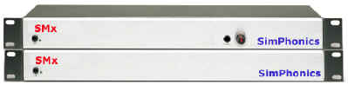

Printed: 7/28/2026

Filename: SMx 16 Channel Test Tutorial

Copyright © 2002, SimPhonics Incorporated
Revision History
Ensure you have the latest release of this document before relying on this information.
Version | Revision | Date
0.1 | Pre-release | Pending
1.00 | Initial Release | February 15, 2002

This document was authored using Microsoft Word 2000 and is maintained at the SimPhonics web site in .DOC format. This document may be copied freely for any purpose.
Contents
Before Reading This Document 4
Files Needed for this Tutorial 4
Introduction 5
V+ Designs 6
Windows Audio Mixer Settings for 16 Channel SMx Design 7
SMx Output Channel Test V+ Design 8
SMx Mixer Setup for WAV Out to Analog Out V+ Design 9
Getting Started 10
Applying/Removing Power 10
Powering Up the System 10
Powering Down the System 10
Loading Files 11
Loading Wave Files 11
Loading V+ Design Files 11
Setting up V+ 12
Configuration 12
Opening the V+ Run Time System (Platform Shell) 12
Configuring the Windows Audio Mixer Driver 13
Configuring the SMx Audio System Driver 13
Loading V+ Design Files 14
Testing the Channels 15
Troubleshooting 16
Check the wavefiles Directory 16
Restart the System 16
Appendix 17
Figures 17
Tables 17
References 18

Before Reading This Document
It is assumed that the reader is familiar with the V+ visual programming system, in particular the use of I/O devices and ports. If not, the reader should become familiar with V+ by downloading the V+ Programming System user manual from the Downloads area of our web site: http://www.simphonics.com/support/downloads/docs/. Also, the user must be familiar with the SMx Audio System, and the associated I/O devices that are part of the SMx Audio System. Read the document “SMXMIX - Mixin it up with SMx.doc” located at: http://www.simphonics.com/support/downloads/docs/ this file explains the layout of the mixer and operation of the SMx in detail.

Files Needed for this Tutorial
All of the files needed for this tutorial are located at: http://www.simphonics.com/library/VPLusSamples/SMx/SMx%20Testing%20Designs/
If you don’t find these files at this exact location, be sure to check the top level folder for SMx testing files, since this information is being updated regularly and the file folder names may have changed to reflect new changes etc.

Introduction
This document illustrates how to test the 16 different SMx channels and make sure all channels are coming out of the right place and being mixed properly. The user is shown how to setup the SMx to play 16 different FXDirect (WAV) players out to 16 discrete channels. While any WAV file could be used for this purpose, this files used in this design example are voice WAV files that actually announce the channel.
Remember that multiple players may be assigned to a single channel, although this example uses a single player per channel. Most actual V+ sound modeling applications use many player per channel.
This example can also be used as a daily readiness test design for testing the output channels of the SMx system. Using voice files for testing does not actually check the amplitude limits, etc., of the SMx, and therefore, sine waves should be used for testing SMx production units.
The diagram below further illustrates the process as a wave-file is generated, mixed by the Windows Audio mixer, then applied to the SMx mixer.

V+ Designs
There are 3 V+ designs needed for this tutorial. Each worksheet performs a specific independent function. The file “SMx Output Channel Test.des” generates 16 discrete waveforms from wavefiles. The Windows operating system exposes a basic mixer for setting the output volume which is controlled by the file “WAM settings 16 Channel Test.des”. Finally the V+ design file “SMx Mixer WO to AO setup.des” for routing these waveforms to the final outputs on the SMx system. These files will be described in more detail later in this document.
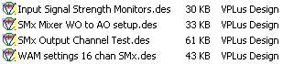

Windows Audio Mixer Settings for 16 Channel SMx Design
The Windows Audio Mixer I/O Device is a generic device for use with any sound card in the PC with a Windows driver. The SMx system exposes a set of controls that are shown in the dialog box below.
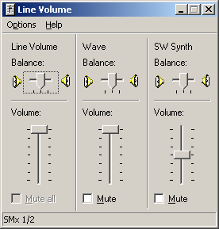
Figure 1 - SMx Line Volume Dialog Box
By using the Windows Audio Mixer Device for V+, V+ can see these controls as ports. Since anyone can come along and adjust these controls in Windows, V+ can override these settings in real-time, allowing V+ control over the WAV output volume, balance, etc. Therefore, no matter what folks may do with these controls in Windows for the SMx, V+ can override the volume settings for the WAV output.
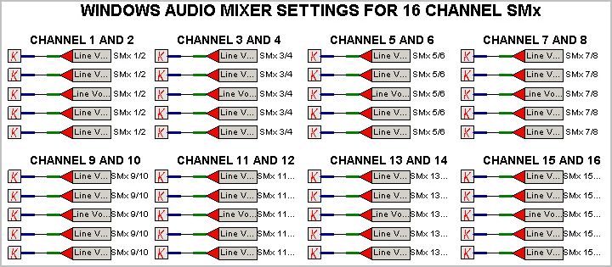
Figure 2 - Windows Audio Mixer Settings V+ Design

SMx Output Channel Test V+ Design
Shown below is the SMx Output Channel test V+ worksheet. This worksheet generates 16 discrete waveforms. Each player object shown on the worksheet below, is associated with a wave-file, and can control the volume, and pitch (frequency) of each waveform as well as an enable and balance control.
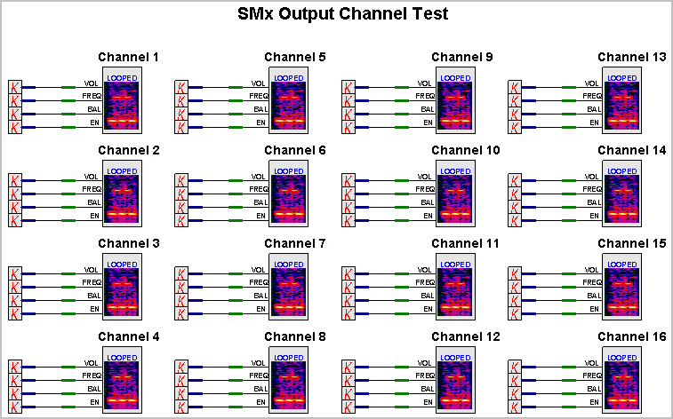
Figure 3 - SMx Output Channel Test V+ Design

SMx Mixer Setup for WAV Out to Analog Out V+ Design
Shown below is the SMx Mixer Setup for Wav out to Analog out V+ worksheet. The file contains ports that control mixer settings on the SMx mixer. The constants driving these ports enable the mixer settings so that the WO (Wave Out) signals are routed to respective AO (Analog Out) of the SMx system hardware.
Note that not only are the channels routed to outputs, but there are master volumes present on the outputs of the SMx mixer that are being enabled also. All constants are 1.0. Ports that are not on the worksheet but part of the SMx mixer, are set to zero by the I/O device.
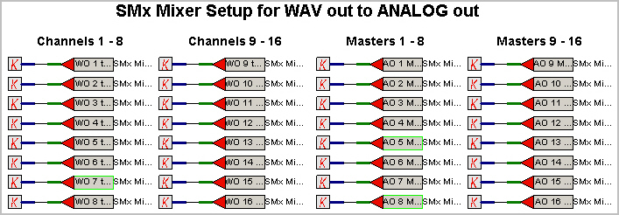
Figure 4 - SMx Mixer Setup for WAV Out to Analog Out V+ Design

Getting Started

Applying/Removing Power
AC power should be applied to each of the SMx components simultaneously or within a few seconds of each other. If power is removed from one of the external chassis’ while the SMx CPU system is running, the system will have to be restarted.

Powering Up the System
- Turn the SMx breakout box and expansion box power on first.
- Then apply power to the computer chassis.
Note: The SMx system does not work properly when it is not powered up in the correct sequence. Turn the SMx breakout box and expansion box power on first. Then apply power to the computer chassis.

Powering Down the System
When powering off the SMx system, shut down the SMx system CPU first, using the shutdown feature of the operating system, and then removing power to the CPU first, and then to the external SMx chassis.
Power
Figure 5 - SMx Breakout Box & Expansion Box
Figure 6 - Chassis

Loading Files
Before using this tutorial you must download WAV files and V+ design files to your computer. There are 16 wav files (one for each channel) and 3 V+ designs. These files are downloaded from our download center at our website: http://www.simphonics.com/library/VPLusSamples/SMx/.
Table 1 - Files Needed for SMx Channel Test
Wave files | V+ design files
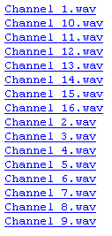

Loading Wave Files
Note: The folder must be placed on the root directory, C:\, and named “wavefiles” or V+ will not be able to locate the files.
To load the WAV files:
- Create a folder in the root directory called “WAVEFILES.”
- Download all wave files and save in the C:\WAVEFILES directory.
Tip: To download WAV files, right click on the WAV link and select Save Target As…. Then save in the WAVEFILES folder you created above in step 1.

Loading V+ Design Files
To load the V+ files:
- Download all the V+ design files listed below and save in your
C:\Program Files\VPLus\designs directory:
SMx Mixer WO to AO setup.des
SMx Output Channel Test.des
WAM settings 16 chan SMx.des

Setting up V+

Configuration
The two I/O devices listed below must be loaded and configured in order to run this test. I/O devices are configured in the V+ Run-Time System (Platform Shell).
2 I/O Devices Needed for this Tutorial
SMx Audio System
Windows Audio Mixer

Both of these devices are automatically installed with every SMx system. However they can also be downloaded from our software download center at SimPhonics web site: http://www.simphonics.com/support/downloads/software/
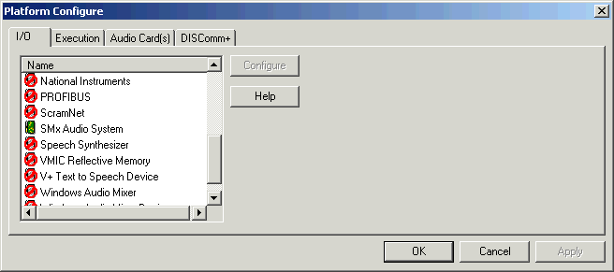
Figure 7 - V+ Platform Configuration dialog box

Opening the V+ Run Time System (Platform Shell)
Use one of the following methods to launch the Run-Time System:
- Select the executable file "vplpltsh.exe" from the "V+" folder in your Windows Explorer.
- Select Programs > V+ > V+ Tools > V+ Run-Time System from the Start menu.
Tip: The Platform Shell can also be launched by first starting the V+ Development System. The Platform Shell automatically loads in a separate window behind the V+ Development System.

Configuring the Windows Audio Mixer Driver
One of the I/O devices needed for this test, is the Windows Audio Mixer Device for V+. This device is installed with the SMx, or may be downloaded separately.
To configure the Windows Audio Mixer I/O device:
- Select Configure from the V+ Run Time System menu. This opens the Platform Configure dialog box.
- Select the I/O Drivers tab from the Platform Configure dialog box.
- *Double click the icon next to the Windows Audio Mixer Device.
- Select OK to close the Platform Configure dialog box.

Configuring the SMx Audio System Driver
The SMx Audio System driver for V+ exposes a number of devices that are used to control and monitor the SMx hardware and software.
To configure the SMx I/O device:
- Select Configure from the V+ Run Time System menu. This opens the Platform Configure dialog box.
- Select the I/O tab from the Platform Configure dialog box.
- *Double click the icon next to the SMX Audio System I/O device.
- Select OK to close the Platform Configure dialog box.
*Note: Below is an example of how the I/O devices appear when they are configured.
This I/O device is configured and ready for use.
This I/O device is not configured.
Figure 8 - Platform Configuration Dialog Box

Loading V+ Design Files
To load the V+ design files:
- Use any of the following methods to open the V+ Visual Programming System:
- Select Tools > Launch V+ from the V+ Run-Time System.
- Select from the V+ Run-Time System shortcut menu.
- Select the executable file "vplus.exe" from the "V+" folder in your Windows Explorer.
- Select Programs > V+ > V+ Tools > V+ Development System from the Start menu.
- Select Open from the File menu.
- Browse for and open each of the 3 V+ design files listed below.
- Once all the V+ design files are open, select Start from the Platform menu or select from the shortcut bar. The following message appears:
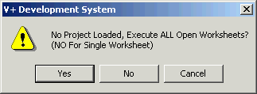
Figure 9 - Executing Worksheet(s)
- Select the Yes button to execute all worksheets.
Note: The status box, located in the lower left corner of the V+ Visual Programming System indicates if the designs have been successfully launched. Once a design is executing, the Messages Area, located in the lower left corner, informs you that your design is running and a green light appears on the V+ Status Bar. Also, a green dashed line appears around all executing objects. Below are graphics showing an object executing and one that is not executing.
Executing... | 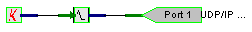
Not executing...

Testing the Channels
Once the WAV files and V+ design files are loaded and V+ is configured and running, the channels can be tested. Test each output with your multimedia headset.
Figure 10 - SMx Breakout Box and Expansion Box – Rear View
To test the channels:
- Plug the multimedia headset into the Channel 1 output
- Listen for the test recording. Repeat steps 1 and 2 for all 16 channels.

Troubleshooting
Problem | Solution
No sound is heard. | Check the WAV Files Directory  Make sure the WAV files are stored in the correct directory. If the folder is not named correctly or is in the wrong location V+ will not be able to locate the files. The folder must be placed on the root directory, C:\, and named “wavefiles.”
Windows is not recognizing the SMx driver. | Restart the System  The SMx system does not work properly when it is not powered up in the correct sequence. Turn the SMx breakout box and expansion box power on first. Then apply power to the chassis. Also, if power is removed from one of the external chassis’ while the SMx CPU system is running, the system will have to be restarted. See Applying/Removing Power for more information.

Appendix

Figures
Figure 1 - SMx Line Volume Dialog Box 7
Figure 2 - Windows Audio Mixer Settings V+ Design 7
Figure 3 - SMx Output Channel Test V+ Design 8
Figure 4 - SMx Breakout Box & Expansion Box 9
Figure 5 - Chassis 9
Figure 6 - V+ Platform Configuration dialog box 11
Figure 7 - Platform Configuration Dialog Box 12
Figure 8 - Executing Worksheet(s) 13
Figure 9 - SMx Breakout Box and Expansion Box – Rear View 14

Tables
Table 1 - Files Needed for SMx Channel Test 7

References
SimPhonics Home Page: http://www.simphonics.com
SMX Audio System Home Page: http://www.simphonics.com/products/systems/smx/

V+, VPLus, SMX, FXDirect are trademarks of SimPhonics, Incorporated.
DSP-LINK is a trademark of Loughborough Sound Images
Copyright © 1998, 1999, 2000, 2001, 2002 SimPhonics Inc. All rights reserved.

