Procedure for Recording ATIS Broadcasts

SimPhonics, Inc.
Printed: 7/28/2026
Filename: ATISP01 - Procedure for Recording ATIS Broadcasts, V1.1
Copyright © 2000, SimPhonics, Incorporated

Revision History

Ensure you have the latest release of this document before relying on this information.

Version | Revision | Date
1.0 | Initial Release to Customer | --
1.1 | Update format for formal release | 5 April 2000

This document was authored using Microsoft Word 97 and is maintained at the SimPhonics web site in .DOC format and HTML format. See the reference Section. This document may be copied freely for any purpose.

For your convenience this document may contain references to web addresses. If you are reading this document on a computer using Microsoft Word or compatible software, clicking these references will point your browser to a location on the web. If you are reading a hard copy, these references will appear as underlined blue text. See SimPhonics home page at www.simphonics.com for more information.

PROCEDURE FOR RECORDING NEW ATIS BROADCASTS

The SimPhonics audio system supports synthetic speech and recorded ATIS (Automatic Terminal Information Service) broadcasts. The synthetic speech ATIS produces computer generated speech from a dynamic ASCII file, while the recorded ATIS system simply plays back previously recorded ATIS broadcasts. These systems are not restricted to ATIS purposes and may be used for generation of speech for any purpose. This procedure outlines the steps for generation of new recorded messages.

For the latest information regarding the synthetic speech system provided on SimPhonics audio systems running under V+, see http://www.simphonics.com/VPLUSTTS/default.htm

THEORY OF OPERATION

The figure below shows the ATIS worksheet for V+ for the DC9 number 5. (Other simulators using the SimPhonics system will have the same design) A sound playback object is used that has filename input pins. The host computer inputs the enable and two filename character variables to this object. As the worksheet shows, the first six filename characters are hard wired to constants. The constants are set to ASCII values of R, C, A, T, I, and S. The host provides the last two so that the player object can play any .WAV file with filenames of RCATIS00 through RCATIS99 which yields over 99 files and this assumes you only use numeric characters.

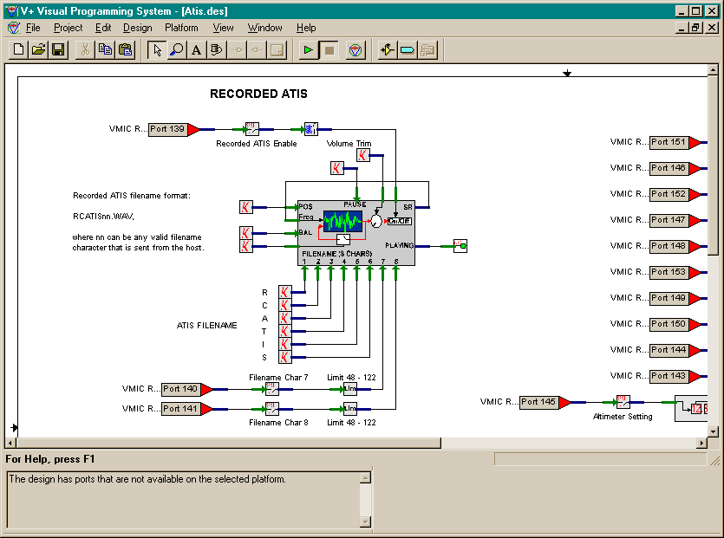

The player object is setup with an internal static data value for the directory where it will look for .WAV files in the c:\WAVEFILES\ directory, which can be changed by the user. (See the V+ User’s Manual for more information on changing static data for objects)

PROCEDURE

Record an ATIS broadcast .WAV file using any suitable .WAV recorder. You can use the recorder that comes with Windows95/98/NT. Any .WAV sample rate will work, although 22kHz, 16bit is recommended. The only requirements are that the file must be mono and in Microsoft .WAV format.

Save the file to a RCATISxx.WAV, where the XX represents a number that will be used at the Instructor station to identify the file. For example RCATIS01.WAV would be file 01, RCATIS02 would be file 02 and so on.

Copy the file onto a floppy.

Insert the floppy into the A driver on the SimPhonics audio system.

Using the SimPhonics audio system keyboard open a DOS command prompt window and copy the file from the floppy to c:\WAVEFILES\. Example:

copy a:\RCATIS01.WAV c:\WAVEFILES\*.*

Restart the system.

When the system restarts, the new file(s) is ready for use.

Note that the use of the floppy method is not the only means of transferring file to the SimPhonics system. There is a network connection that can also be used.

