V⁺ Shared Memory I/O Device
User Manual

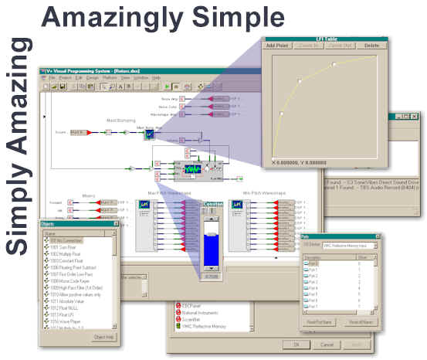

SimPhonics Incorporated
Printed: 7/28/2026
V+ Shared Memory Device User Manual, V1.0
Filename: input.doc
Copyright © 1999, SimPhonics Incorporated

PREFACE

This document represents SimPhonics' User Manual for the V+ Shared Memory I/O Device. V+, pronounced "V - Plus", is a completely new way of programming systems that interact with real-world signals in real-time. This I/O device is an add-on to V+ that allows the visual language to access shared in order to share memory with other applications in real-time.

Please note that this manual is a living document, which will be under the revision process rather frequently as more enhancements are added to the system. Therefore, be sure you have the latest version of this document.

BEFORE USING THIS DOCUMENT

You must be familiar with V+ in order to use this document. Be sure to read the V+ User Manual before proceeding. See: http://www.simphonics.com/vplus. This I/O device may also be downloaded at: http://www.simphonics.com/VPLusFMDev/default.htm

WHAT IS THE V+ SHARED MEMORY I/O DEVICE?

The device is a software component add-on to V+, a visual programming language which allows V+ to share memory with other applications running on the same machine.

HOW DOES IT WORK?

This device shares memory via the Windows File Mapping mechanism. For more information on the windows file Mapping system, see section

File mapping is the association of a file's contents or a memory area's contents with a portion of the virtual address space of a process. The system creates a file-mapping object to maintain this association. A file view is the portion of virtual address space that the process uses to access the data. Processes read from and write to the file view using pointers, just as they would with dynamically allocated memory. The file-mapping functions allow a process to create file-mapping objects and file views to easily access and share data.
Each file mapping area (shared memory area) is accessible via a string name. Each area has a unique string name. This I/O device create new areas for other applications to share, otr open existing areas that applications have created.

SOFTWARE INSTALLATION

Before installing this device, you must first install V+. You can obtain an evaluation copy at http://www.simphonics.com/VPLus/vplusdnld.htm. Contact SimPhonics for the current password if needed.

Once V+ is installed, this device installation is simple and requires only a few steps. First, obtain the media that you will use for the installation. The device is shipped on floppy or can be downloaded form the Internet.

Insert the media and execute the setup program on the disk. The setup executable program is SETUPEX.EXE. Execute this file and follow the instructions. Remember to remove the media when completed. Use the default settings that the setup system requests. The software will install the V+ I/O Device DLL, the Microsoft Speech Engine, and some documentation and samples as well as a few registry entries.

DEVICE CONFIGURATION

This device is loaded the same as any other V+ device in the run-time system; by double-clicking on the device name in the I/O device list, and clicking the Configure button.

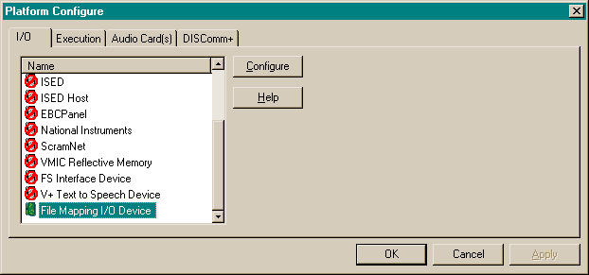

Once the Configure button is selected, the configuration dialog box is displayed. A file mapping area name is typed into the File Map Name field. Clicking the Find/Create button will either open an existing file map or create a new one if the name is not found.

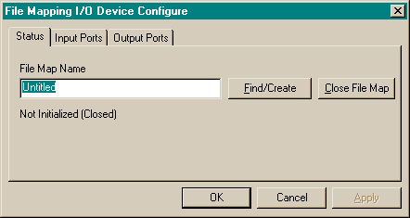

Input and output devices are configured by selecting the INPUT or OUTPUT tab on the CONFIGURE dialog box. Both input and output configuration dialog boxes are shown below, which controls the number of ports and the offset into the file map area. All data is represented by IEEE 32 bit floats.

